A PROJECT REPORT ON
DISCOVERING KNEE OSTEOARTHRITIS USING CNN ENHANCED WITH ALEX NET
A project report submitted in partial fulfillment of the requirements for the award of the degree of

BACHELOR OF TECHNOLOGY IN
COMPUTER SCIENCE & ENGINEERING (ARTIFICIAL INTELLIGENCE)

Submitted By

B.Mahaboob Chand 222P1A3107
B. Sri Harika Padma Latha 222P1A3109
M. Prathima 222P1A3123
R. Amrina 222P1A3139
S. Muskan 222P1A3145

Under The Esteemed Guidance Of

Ms. Sujatha
Assit. Professor, Dept. of CSE



DEPARTMENT OF COMPUTER SCIENCE AND ENGINEERING
(ARTIFICIAL INTELLIGENCE)

AN ISO 9001:2015 CERTIFIED INSTITUTION
CHAITANYA BHARATHI INSTITUTE OF TECHNOLOGY (AUTONOMOUS)
(Sponsored by Bharathi Educational Society)
(Affiliated to J.N.T.U.A., Anantapuramu, Approved by AICTE, NewDelhi)
Recognized by UGC Under the Sections 2(f)&12(B) of UGC Act, 1956
(Accredited by NAAC & NBA) Vidyanagar,Proddatur-516360,Y.S.R.(Dist.),A.P.
2022-2026



CERTIFICATE

This is to certify that the project work entitled “ DISCOVERING KNEE OSTEOARTHRITIS USING CNN ENHANCED WITH ALEX NET” is a bonafide work of B.MAHABOOB CHAND(222P1A3107),B.SRIHARIKAPADMALATHA(222P1A3109),M.PRATHIMA(222P1A3123),R.AMRINA(222P1A3139), S.MUSKAN(222P1A3145) submitted to Chaitanya Bharathi Institute of Technology, Proddatur in partial fulfillment of the requirements for the award of the degree of Bachelor of Technology in COMPUTER SCIENCE AND ENGINEERING(ARTIFICIAL INTELLIGENCE) The work reported here in does not form part of any other thesis on which a degree has been awarded earlier. This is to further certify that they have worked for a period of one semester for preparing their work under our supervision and guidance.

Internal Guide Head of the Department
Ms. S.Sujatha Mrs.M. Lakshmi Madhuri
Assit. Professor, Dept.of CSE Assit.Professor,Dept.of CSE & HOD-CSE(AI)

Project Co-Ordinator
Dr. P. PavanKumar
Asso.Professor, Dept.of CSE

Internal Examiner External Examiner

DECLARATION BY THE CANDIDATES

We are B. Mahaboob Chand, B. Sri Harika Padma Latha, M. Prathima, R. Amrina, S. Muskan respective RollNo: (222P1A3107), (222P1A3109), (222P1A3123), (222P1A3139), (222P1A3145) here
By declare that the Project Report entitled “DISCOVERING KNEE OSTEOARTHRITIS USING CNN ENHANCED WITH ALEX NET” under the guidance of Ms. Sujatha, Assit. Professor, Department of CSE is submitted in partial fulfillment of the requirements for the award of the degree of Bachelor of Technology in Computer Science & Engineering (Artificial Intelligence).

This is record of bonafide work carried out by us and the results embodied in this Project
Report have not been reproduced or copied from any source. The results embodied in this Project Report have not been submitted to any other University or Institute for the Award of any other Degree or Diploma.

B. MAHABOOB CHAND 222P1A3107

B. SRI HARIKA PADMA LATHA 222P1A3109

M. PRATHIMA 222P1A3123

R. AMRINA 222P1A3139

S. MUSKAN 222P1A3145

Dept. of Computer Science and Engineering
(Artificial Intelligence)
Chaitanya Bharati Institute Of Technology
Vidyanagar,Proddatur,Y.S.R.(Dist.)

ACKNOWLEDGEMENT

An endeavour over along period can be successful only with the advice and support of many well-wishers.We take this opportunity to express our gratitude and appreciation to all of them.

We are extremely thankful to our beloved Chairman Dr.V.Jayachandra Reddy who took keen interest and encouraged us in every effort throughout this course.

We owe our gratitude to our Principal Dr. S. Sruthi M.Tech.,Ph.D.for permitting us to use the facilities available to accomplish the project successfully.

We express our heartfelt thanks to Mrs.M.Lakshmi Madhuri Assit. Professor, Head of Dept.CSE(AI) for her kind attention and valuable guidance to us throughout this course.

We also express our deep sense of gratitude towards Ms. Sujatha Assit. Professor, Dept.of CSE for her support and guidance in completing our project.

We express our profound respect and gratitude to our project coordinator Dr.P.PavanKumar Asso. Professor, for his valuable support and guidance in completing the project successfully.

We also thank all the teaching & Non-teaching staff of the Dept.of CSE for their support throughout our B.Tech course.
We express our heartful thanks to our parents for their valuable support and encouragement in completion of our course. Also, we express our heartful regards to our friends for being supportive in completion of the project.

CONTENT | PAGE NO
Abstract | 7
1.INTRODUCTION | 8 – 10
1.1 Motivation | 8
1.2 Problem Statement | 8
1.3 Objective of the Project | 9
1.4 Scope | 9
1.5 Project Introduction | 10
2.LITERATURE SURVEY | 11 - 13
2.1 Related Work | 11 - 13
3. SYSTEM ANALYSIS | 13 - 15
3.1 Existing System | 13
3.2 Disadvantages | 13
3.3 Proposed System | 14
3.4 Advantages | 14
3.5 work Flow of Proposed system | 15
4. REQUIREMENT ANALYSIS | 16 - 18
4.1 Function and non-functional requirements | 16
4.2 Hardware Requirements | 16
4.3 Software Requirements | 17
4.4 Architecture | 18
5. METHODOLOGY | 18 - 21
5.1 Mobile Net Algorithm | 18 - 19
5.2 AlexNet Algorithm | 19 - 20
5.3 ResNet-50 Algorithm | 20 - 21
6. SYSTEM DESIGN | 22 - 32
6.1 Introduction of Input design | 22 - 23
6.2 UML Diagram (class, use case, sequence, collaborative, deployment, activity, ER diagram and Component diagram) | 24 - 32
7. IMPLEMENTATION AND RESULTS | 33 – 38
7.1 Modules | 33
- Output Screens | 34 - 38
8. SYSTEM STUDY AND TESTING | 39 - 42
8.1 Feasibility study | 39 – 40
8.2 Types of test & Test Cases | 41 - 42
9. CONCLUSION | 43
10. FUTURE ENHANCEMENT | 43
11. REFERENCES | 44 – 45
BIBLIOGRAPHY | 46 – 64
APPENDIX | 65 - 75

Abstract
The advancement of knee injury diagnosis plays a pivotal role in enhancing the treatment of such conditions, demanding both precision and cost-effectiveness. In recent years, the landscape of knee injury detection in X-ray studies has been predominantly shaped by deep learning methodologies. This paper aims to present the outcomes derived from a comprehensive systematic literature review focused on knee injury detection – ranging from doubtful, healthy, minimal, moderate, to severe cases – leveraging deep learning techniques. Selected metrics have been employed to discern and interpret the research findings.
The prediction accuracy of deep learning models, specifically AlexNet, MobileNet, and ResNet, for identifying knee injuries exhibited a noteworthy range of 72.5% to 100%. These deep learning architectures demonstrate the potential to match or even surpass human-level performance in decision-making tasks associated with X-ray-based knee injury diagnoses. However, it is crucial to acknowledge certain limitations inherent in current deep learning approaches, including challenges related to data imbalance, generalizability across different medical centers, verification bias, and a notable scarcity of classification studies encompassing more than two injury classes. Additionally, the subjectivity in defining ground truth poses a challenge to the robustness of these models.
Further exploration of deep learning in the domain of X-ray-based knee injury diagnosis is warranted. Addressing issues such as explainability and lightweight deployment of deep learning systems is expected to be instrumental in fostering their widespread adoption within clinical practices.
Keywords: Orthopedics, Knee X-ray images, Classification, Deep Learning, AlexNet, MobileNet, ResNet.

1. INTRODUCTION
1.1 Motivation:
The motivation for this project stems from the existing challenges in accurately diagnosing knee osteoarthritis using traditional methods. The limitations in precision and timeliness in current diagnostic approaches highlight the need for a more sophisticated system. By leveraging deep learning techniques and advanced neural network architectures, the project aspires to contribute to medical advancements, providing a solution that improves the precision and efficiency of knee osteoarthritis diagnosis, ultimately enhancing patient care and outcomes.
1.2 Problem Statement
The project addresses the challenge of accurately diagnosing knee osteoarthritis, a prevalent joint ailment, using conventional diagnostic methods that may lack precision and efficiency. The current methods often rely on subjective interpretations and may not detect early indicators of the condition, leading to delayed intervention and suboptimal patient outcomes. Therefore, there is a critical need for a robust and efficient diagnostic system capable of early detection and precise identification of knee osteoarthritis, thereby facilitating timely intervention and improving patient care.
1.3 Objective of the Project:
- Enhanced Diagnostics: Implement a specialized Convolutional Neural Network (CNN) with integrated architectures from AlexNet, MobileNet, and ResNet to improve precision in knee osteoarthritis diagnosis.
- Early Detection: Utilize deep learning techniques to identify initial indicators, enabling timely intervention for knee osteoarthritis, ultimately contributing to enhanced patient outcomes.
- Architectural Integration: Integrate advanced neural network architectures to optimize the system's ability to analyze complex medical imaging datasets, fostering a more comprehensive and accurate diagnostic process.
- Medical Advancements: Contribute to the progress in medical diagnostics by developing a novel framework for addressing prevalent joint ailments, particularly knee osteoarthritis. This approach showcases the potential for significant advancements in early detection and intervention strategies, ultimately improving patient care.

1.4 Scope:
- Utilizing Specialized CNN with AlexNet Architecture: Implementing a dedicated Convolutional Neural Network (CNN) enriched with the advanced architecture of AlexNet to create a robust framework for knee osteoarthritis detection.
- Enhanced Diagnostic Accuracy: Analyzing medical imaging data using deep learning techniques to achieve superior diagnostic accuracy, providing healthcare professionals with more precise information for effective decision-making.
- Early Detection Capabilities: Developing and implementing early detection capabilities within the system to identify initial indicators of knee osteoarthritis. This aims to facilitate timely intervention and improve patient outcomes.
- Integration of Advanced Neural Network Architectures: Exploring the integration of advanced neural network architectures, including MobileNet and ResNet, to optimize the system's ability to process and interpret complex medical imaging datasets. This integration enhances the overall efficiency and effectiveness of the diagnostic process.
1.5 Project Introduction:
Knee injuries represent a substantial portion of severe sport-related injuries, with significant societal and economic implications. Anterior cruciate ligament (ACL) ruptures, comprising over 50% of cases, affect around 200,000 individuals annually in the United States. Knee cartilage lesions impact approximately 900,000 Americans yearly, leading to over 200,000 surgical procedures. Menisci injuries, the second most common knee impairment, have an incidence of 12–14% and a prevalence of 60–70 cases per 100,000 in the United Kingdom. ACL injuries alone incur expenditures exceeding $7 billion in the United States.
Knee injuries result in both short- and long-term pain, disability, and adversely affect health-related quality of life. Particularly in young and athletic individuals, prolonged engagement in occupational or recreational activities heightens the susceptibility to knee injuries, contributing to an increased risk of developing osteoarthritis (OA). Remarkably, about half of individuals with ACL and/or meniscal tear injuries develop radiographically confirmed knee OA within ten to 20 years post-injury. Additionally, knee injuries can lead to structural muscle injuries of the lower limb and tendinopathies.
The socio-economic burden of knee injuries extends beyond direct medical costs, encompassing lost wages, productivity, and disability. The prevalence of knee injuries necessitates the development of accurate and cost-effective detection methods to quantify injury severity. Early diagnosis and treatment of ligament ruptures, menisci tears, and cartilage lesions can prevent the premature onset of knee OA.
While arthroscopy is considered the "gold standard" for intra-articular knee pathology diagnosis, its invasiveness and potential complications limit its utility. Magnetic resonance imaging (MRI) is the widely adopted non-invasive imaging technique for knee injury diagnosis. However, interpreting X-ray-based knee injury diagnoses can be challenging, with clinician experience playing a pivotal role. Human-based interpretation pitfalls, such as subjectivity, distraction, and fatigue, often lead to inconsistent diagnoses, hindering optimal injury management.
The advent of artificial intelligence (AI), specifically deep learning (DL), offers promising solutions to improve knee injury diagnosis. DL, a subset of machine-learning algorithms, has shown success in various
medical image analyses. In the context of knee injuries, early DL studies have exhibited superior performance compared to traditional machine-learning techniques and, in some cases, even outperformed radiologists. However, previous reviews in the X-ray domain lacked a specific focus on knee injuries.
In this paper, we conducted a systematic literature review to comprehensively explore DL techniques employed in the X-ray-based diagnosis of knee injuries. The primary focus is on studies investigating pathologies such as Doubtful, Healthy, Minimal, Moderate, and Severe conditions. The review aims to highlight recent advancements, learning methodologies, processing stages, and technical limitations associated with DL technology in knee injury diagnosis, contributing to the growing body of knowledge in this evolving field.

2. LITERATURE REVIEW
- Anifah, L., Purnomo, M., Mengko, T., Purnama, I.: Osteoarthritis severity determination using self organizing map based Gabor kernel. In: IOP Conference Series: Materials Science and Engineering, vol. 306, p. 012071. IOP Publishing (2018)
The number of osteoarthritis patients in Indonesia is enormous, so early action is needed in order for this disease to be handled. The aim of this paper to determine osteoarthritis severity based on x-ray image template based on gabor kernel. This research is divided into 3 stages, the first step is image processing that is using gabor kernel. The second stage is the learning stage, and the third stage is the testing phase. The image processing stage is by normalizing the image dimension to be template to 50 □ 200 image. Learning stage is done with parameters initial learning rate of 0.5 and the total number of iterations of 1000. The testing stage is performed using the weights generated at the learning stage. The testing phase has been done and the results were obtained. The result shows KL-Grade 0 has an accuracy of 36.21%, accuracy for KL-Grade 2 is 40,52%, while accuracy for KL-Grade 2 and KL-Grade 3 are 15,52%, and 25,86%. The implication of this research is expected that this research as decision support system for medical practitioners in determining KL-Grade on X-ray images of knee osteoarthritis.
- Antony, J., McGuinness, K., O’Connor, N.E., Moran, K.: Quantifying radiographic knee osteoarthritis severity using deep convolutional neural networks. In: 2016 23rd International Conference on Pattern Recognition (ICPR), pp. 1195–1200. IEEE (2016)
This paper proposes a new approach to automatically quantify the severity of knee osteoarthritis (OA) from radiographs using deep convolutional neural networks (CNN). Clinically, knee OA severity is assessed using Kellgren \& Lawrence (KL) grades, a five point scale. Previous work on automatically predicting KL grades from radiograph images were based on training shallow classifiers using a variety of hand engineered features. We demonstrate that classification accuracy can be significantly improved using deep convolutional neural network models pre-trained on ImageNet and fine-tuned on knee OA images. Furthermore, we argue that it is more appropriate to assess the accuracy of automatic knee OA severity predictions using a continuous distance-based evaluation metric like mean squared error than it is to use classification accuracy. This leads to the formulation of the prediction of KL grades as a regression problem and further improves accuracy. Results on a dataset of X-ray images and KL grades from the Osteoarthritis Initiative (OAI) show a sizable improvement over the current state-of-the-art.
- He, K., Sun, J., Tang, X.: Guided image filtering. IEEE Trans. Pattern Anal. Mach. Intell. 6, 1397–1409 (2013)
In this paper, we propose a novel explicit image filter called guided filter. Derived from a local linear model, the guided filter computes the filtering output by considering the content of a guidance image, which can be the input image itself or another different image. The guided filter can be used as an edge-preserving smoothing operator like the popular bilateral filter [1], but it has better behaviors near edges.

The guided filter is also a more generic concept beyond smoothing: It can transfer the structures of the guidance image to the filtering output, enabling new filtering applications like dehazing and guided feathering. Moreover, the guided filter naturally has a fast and nonapproximate linear time algorithm, regardless of the kernel size and the intensity range. Currently, it is one of the fastest edge-preserving filters. Experiments show that the guided filter is both effective and efficient in a great variety of computer vision and computer graphics applications, including edge-aware smoothing, detail enhancement, HDR compression, image matting/feathering, dehazing, joint upsampling, etc.
- Hegadi, R.S., Kamble, P.M.: Recognition of Marathi handwritten numerals using multi-layer feed-forward neural network. In: 2014 World Congress on Computing and Communication Technologies (WCCCT), pp. 21–24. IEEE (2014)
Marathi is one of the ancient Indian languages majorly spoken in the state of Maharashtra. Marathi is one of the Devanagari script and the literals and numerals are almost similar to Hindi. Recognition of handwritten Marathi numerals is quite challenging task because people have the practice of writing these numerals in variant ways. In this work we have presented a method to recognize the handwritten Marathi numerals using multilayer feed-forward neural network. The scanned document image is pre-processed to eliminate the noise and care is taken to link the broken characters. Each numeral is segmented from the document and it is resized to 7 × 5 pixels using cubic interpolation. While resizing a technique is used to provide better representation for every pixel in segmented numeral. This resized numeral is converted into a vector with 35 values before inputting it to the neural network. We have used 100 sets containing 1000 numerals for this experimentation, of which 50 sets are used for training the network and 50 sets for the testing purpose. The overall recognition rate of the proposed method is 97%.
- Mishra, M., Srivastava, M.: A view of artificial neural network. In: 2014 International Conference on Advances in Engineering and Technology Research (ICAETR), pp. 1–3. IEEE (2014)
In this paper, An Artificial Neural Network or ANN, its various characteristics and business applications. In this paper also show that “what are neural networks” and “Why they are so important in today's Artificial intelligence?” Because various advances have been made in developing intelligent system, some inspired by biological neural networks. ANN provides a very exciting alternatives and other application which can play important role in today's computer science field. There are some Limitations also which are mentioned.

3. SYSTEM ANALYSIS
3.1 Existing System
This model emphasizes an existing method that is designed using some of the algorithms of deep learning. Here, the process is performed using CNN, which is one of the transfer learning methods, but it has encountered challenges in achieving high accuracy.
Disadvantages:
- Less Feature Compatibility:
The model exhibits limitations in terms of feature compatibility, possibly hindering its ability to effectively capture and analyze relevant features from the input data.
- Low Accuracy:
Despite utilizing CNN and transfer learning, the model faces challenges in achieving high accuracy, indicating potential shortcomings in its ability to precisely identify and classify knee osteoarthritis indicators.
Addressing these disadvantages is crucial for optimizing the model's performance and ensuring its effectiveness in enhancing diagnostic accuracy and enabling early detection.
3.2 Disadvantages:
- Computational Complexity: The utilization of advanced architectures such as AlexNet, MobileNet, and ResNet introduces increased computational demands, potentially requiring substantial resources. Managing the computational complexity becomes crucial for practical deployment.
- Processing Time: The sophisticated features of AlexNet, MobileNet, and ResNet may lead to extended processing times, particularly when dealing with large medical imaging datasets. Real-time results could be affected, and careful consideration is needed for efficient processing.
- Resource Requirements: The enhanced architectures may demand significant computational resources, limiting practicality in settings with constraints. Balancing the trade-off between model complexity and resource availability is essential for widespread applicability.
- Optimization Challenges: Careful optimization strategies are necessary to address the computational complexities of AlexNet, MobileNet, and ResNet. Achieving a balance between high accuracy and efficient deployment requires meticulous optimization.
- Deployment Practicality: The disadvantages include potential limitations in deploying the models in environments with restricted computational capabilities. Considering the practicality of implementing advanced architectures like MobileNet and ResNet becomes crucial for successful deployment in diverse healthcare settings.

3.3 Proposed System:
The proposed methodology integrates a specialized Convolutional Neural Network (CNN) with AlexNet, MobileNet, and ResNet architectures for comprehensive knee osteoarthritis detection. The process commences with meticulous data preprocessing, optimizing the dataset for training. The constructed CNN model, enriched with features from AlexNet, MobileNet, and ResNet, undergoes rigorous training and performance evaluation. Key metrics guide optimization, providing insights into the strengths and limitations of each architecture. This multi-architectural approach aims to elevate the accuracy of knee osteoarthritis detection, showcasing the potential advancements achievable through the fusion of CNN, AlexNet, MobileNet, and ResNet capabilities in medical diagnostics.
3.4 Advantages:
- Enhanced Pattern Recognition: The utilization of a Convolutional Neural Network (CNN) enriched with AlexNet, MobileNet, and ResNet features facilitates superior pattern recognition. This amalgamation allows the model to capture intricate details in knee images, enhancing its diagnostic capabilities.
- Hierarchical Learning: The hierarchical learning capabilities of the enhanced CNN, combined with MobileNet and ResNet architectures, contribute to a more nuanced understanding of knee osteoarthritis features. This synergistic approach potentially improves diagnostic accuracy by considering various hierarchical representations.
- Flexibility: The proposed method, incorporating features from AlexNet, MobileNet, and ResNet, exhibits flexibility in adapting to diverse datasets. This adaptability makes the model applicable to different scenarios, contributing to its versatility across various medical imaging datasets.
- Comparative Analysis: The method enables a comprehensive comparative analysis with existing approaches, providing insights into its efficacy and potential advancements in knee osteoarthritis discovery.
- Potential for Further Research: The proposed method sets the stage for potential further research and improvements, fostering advancements in the field of medical image analysis and disease detection.

3.5 Project Flow:

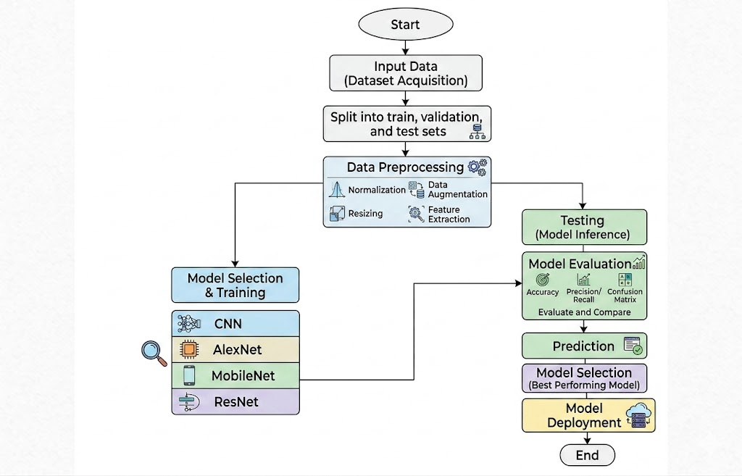

4. REQUIREMENT ANALYSIS
4.1 Functional and non-functional requirements:
Requirement’s analysis is very critical process that enables the success of a system or software project to be assessed. Requirements are generally split into two types: Functional and non-functional requirements.
Functional Requirements: These are the requirements that the end user specifically demands as basic facilities that the system should offer. All these functionalities need to be necessarily incorporated into the system as a part of the contract. These are represented or stated in the form of input to be given to the system, the operation performed and the output expected. They are basically the requirements stated by the user which one can see directly in the final product, unlike the non-functional requirements.
Examples of functional requirements:
- Authentication of user whenever he/she logs into the system
- System shutdown in case of a cyber-attack
- A verification email is sent to user whenever he/she register for the first time on some software system.
Non-functional requirements: These are basically the quality constraints that the system must satisfy according to the project contract. The priority or extent to which these factors are implemented varies from one project to other. They are also called non-behavioral requirements.
They basically deal with issues like:
- Portability
- Security
- Maintainability
- Reliability
- Scalability
- Performance
- Reusability
- Flexibility
Examples of non-functional requirements:
- Emails should be sent with a latency of no greater than 12 hours from such an activity.
- The processing of each request should be done within 10 seconds
- The site should load in 3 seconds whenever of simultaneous users are > 10000

  - Hardware Requirements

Processor - I3/Intel Processor
Hard Disk - 160GB
Key Board - Standard Windows Keyboard
Mouse - Two or Three Button Mouse
Monitor - SVGA
RAM - 8GB
  - Software Requirements:
Operating System : Windows 7/8/10
Server-side Script : HTML, CSS, Bootstrap & JS
Programming Language : Python
Libraries : Flask, Pandas, MySQL. Connector, NumPy, tensorflow, keras, sklearn
IDE/Workbench : PyCharm
Technology : Python 3.6+
Server Deployment : Xampp Server
Database : MySQL

4.4 Architecture

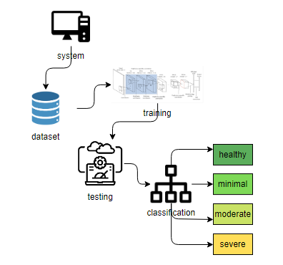

5. METHODOLOGY
5.1 MobileNet:
MobileNet, a convolutional neural network designed for optimal efficiency on mobile and edge devices, serves as the fundamental architecture in our knee osteoarthritis detection system. Developed by Howard et al. in 2017, this network prioritizes computational efficiency without compromising performance.
MobileNet has a depth of 28 layers, utilizing depthwise separable convolutions to achieve a lightweight design. This innovation significantly reduces the number of parameters, making the model well-suited for deployment in resource-constrained environments.
Trained using transfer learning on a carefully curated dataset of knee X-ray images, MobileNet adapts to various osteoarthritis severity levels through fine-tuning. The model's performance is evaluated using standard metrics such as accuracy, precision, recall, and F1 score, providing a comprehensive assessment of its effectiveness.
The compact size of MobileNet enhances its appeal, particularly for real-time processing of knee X-ray images in clinical settings with limited computational resources. Its computational efficiency positions MobileNet as a valuable tool in advancing diagnostic procedures for knee-related pathologies.
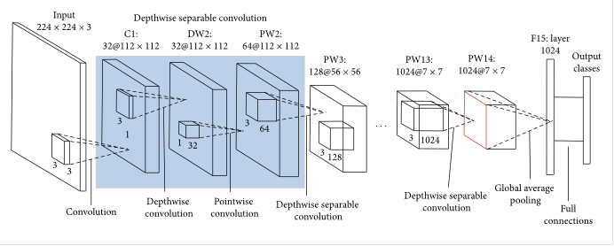
In summary, the integration of MobileNet into our knee osteoarthritis detection framework exemplifies the potential of lightweight architectures to efficiently and accurately analyze medical images, contributing to improved diagnostic capabilities.

  - AlexNet:
AlexNet, a pioneering convolutional neural network, has been incorporated into our knee osteoarthritis detection framework to enhance the accuracy and efficacy of the model. Developed by Alex Krizhevsky, Ilya Sutskever, and Geoffrey Hinton in 2012, AlexNet gained prominence for its success in the ImageNet Large Scale Visual Recognition Challenge.
With a substantial depth of eight layers, AlexNet stands out for its architectural innovations, including the use of rectified linear units (ReLU) and local response normalization. This deep architecture enables the extraction of intricate features crucial for image classification tasks.
Trained on diverse knee X-ray images, the AlexNet-enhanced model undergoes transfer learning and fine-tuning to adapt to the nuances of osteoarthritis detection. The dataset encompasses various severity levels, ensuring the model's ability to accurately categorize different knee conditions.
Performance evaluation involves standard metrics such as accuracy, precision, recall, and F1 score, providing a comprehensive understanding of the model's diagnostic capabilities. AlexNet's proficiency in image classification tasks, coupled with its adaptability to medical imaging, positions it as a valuable asset in knee osteoarthritis detection.
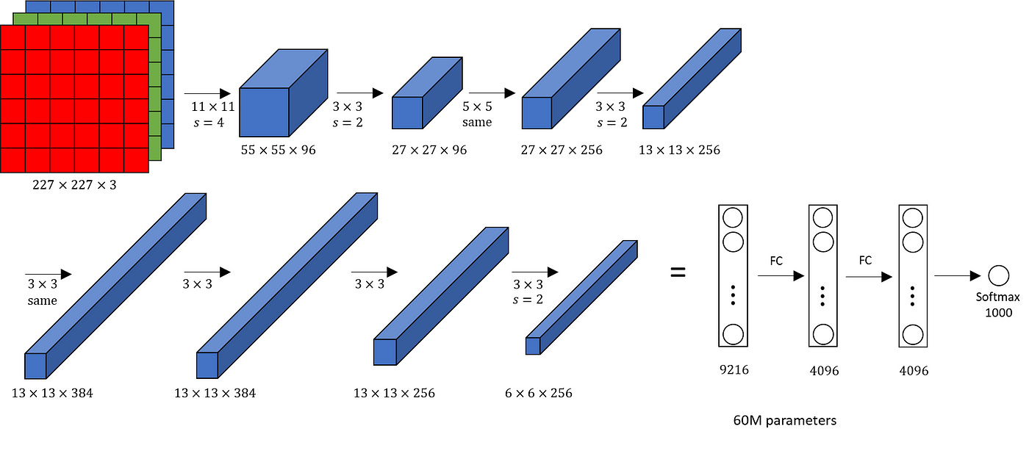
While not as lightweight as some newer architectures, the robust features and proven success of AlexNet contribute to its significance in medical image analysis. The integration of AlexNet into our framework exemplifies its potential to enhance diagnostic accuracy and advance the field of knee-related pathology detection.
  - ResNet:
ResNet152V2, a powerful and deep convolutional neural network, is integral to our knee osteoarthritis detection framework, providing enhanced capabilities for accurate and intricate image analysis. Developed by Kaiming He, Xiangyu Zhang, Shaoqing Ren, and Jian Sun in 2016, ResNet152V2 represents an evolution of the ResNet architecture, specifically designed for complex visual recognition tasks.
With an impressive depth of 152 layers, ResNet152V2 employs residual learning, allowing the network to efficiently train deeper architectures without encountering the vanishing gradient problem. This depth facilitates the extraction of intricate features crucial for precise medical image classification.
The model is trained on a diverse dataset of knee X-ray images, covering a spectrum of osteoarthritis conditions, from Doubtful to Severe. Transfer learning is applied to leverage pre-trained weights, and fine-tuning ensures the model adapts to the specifics of knee pathology detection.
Performance evaluation encompasses standard metrics such as accuracy, precision, recall, and F1 score, providing a holistic assessment of the model's diagnostic prowess. ResNet152V2's sophisticated architecture and depth make it well-suited for discerning patterns in medical images, contributing to improved detection capabilities.
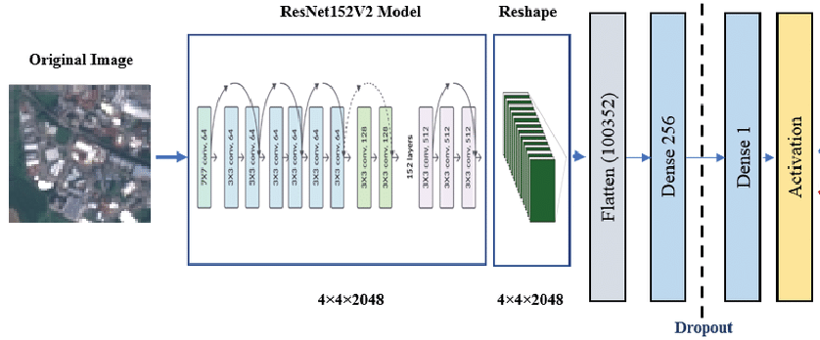
While ResNet152V2 may be computationally intensive compared to lighter architectures, its ability to capture nuanced features positions it as a valuable asset in the realm of knee osteoarthritis detection. The integration of ResNet152V2 into our framework underscores its potential to elevate diagnostic accuracy and advance the field of medical image analysis.

6. SYSTEM DESIGN
6.1 Introduction of Input Design:
In an information system, input is the raw data that is processed to produce output. During the input design, the developers must consider the input devices such as PC, MICR, OMR, etc.
Therefore, the quality of system input determines the quality of system output. Well-designed input forms and screens have following properties −
- It should serve specific purpose effectively such as storing, recording, and retrieving the information.
- It ensures proper completion with accuracy.
- It should be easy to fill and straightforward.
- It should focus on user’s attention, consistency, and simplicity.
- All these objectives are obtained using the knowledge of basic design principles regarding −
  - What are the inputs needed for the system?
  - How end users respond to different elements of forms and screens.

Objectives for Input Design:
The objectives of input design are −
- To design data entry and input procedures
- To reduce input volume
- To design source documents for data capture or devise other data capture methods
- To design input data records, data entry screens, user interface screens, etc.
- To use validation checks and develop effective input controls.

Output Design:
The design of output is the most important task of any system. During output design, developers identify the type of outputs needed, and consider the necessary output controls and prototype report layouts.

Objectives of Output Design:
The objectives of input design are:
- To develop output design that serves the intended purpose and eliminates the production of unwanted output.
- To develop the output design that meets the end user’s requirements.
- To deliver the appropriate quantity of output.
- To form the output in appropriate format and direct it to the right person.
- To make the output available on time for making good decisions.

6.2 UML Diagrams:
UML stands for Unified Modelling Language. UML is a standardized general-purpose modelling language in the field of object-oriented software engineering. The standard is managed, and was created by, the Object Management Group.
The goal is for UML to become a common language for creating models of object-oriented computer software. In its current form UML is comprised of two major components: a Meta-model and a notation. In the future, some form of method or process may also be added to; or associated with, UML.
The Unified Modelling Language is a standard language for specifying, Visualization, Constructing and documenting the artifacts of software system, as well as for business modelling and other non-software systems.
The UML represents a collection of best engineering practices that have proven successful in the modelling of large and complex systems.
The UML is a very important part of developing objects-oriented software and the software development process. The UML uses mostly graphical notations to express the design of software projects.
Goals:
The Primary goals in the design of the UML are as follows:
- Provide users a ready-to-use, expressive visual modelling Language so that they can develop and exchange meaningful models.
- Provide extendibility and specialization mechanisms to extend the core concepts.
- Be independent of particular programming languages and development process.
- Provide a formal basis for understanding the modelling language.
- Encourage the growth of OO tools market.
- Support higher level development concepts such as collaborations, frameworks, patterns and components.
- Integrate best practices.
Use Case Diagram
- A use case diagram in the Unified Modeling Language (UML) is a type of behavioral diagram defined by and created from a Use-case analysis.
- Its purpose is to present a graphical overview of the functionality provided by a system in terms of
- of actors, their goals (represented as use cases), and any dependencies between those use cases.
The main purpose of a use case diagram is to show what system functions are performed for which actor. Roles of the actors in the system can be depicted

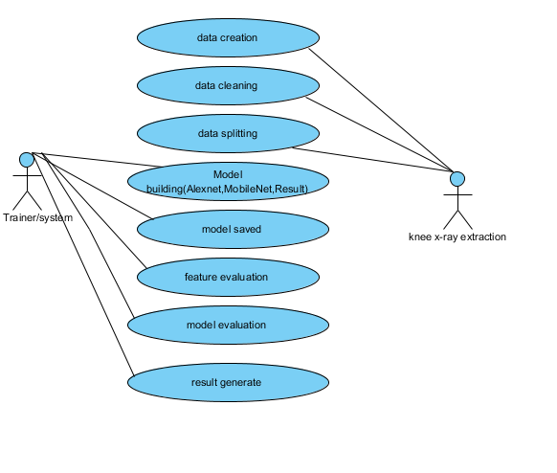

Class Diagram:
In software engineering, a class diagram in the Unified Modeling Language (UML) is a type of static structure diagram that describes the structure of a system by showing the system's classes, their attributes, operations (or methods), and the relationships among the classes. It explains which class contains information.

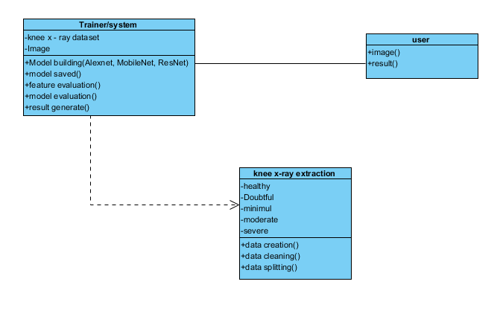

Sequence Diagram:
- A sequence diagram in Unified Modeling Language (UML) is a kind of interaction diagram that shows how processes operate with one another and in what order.
- It is a construct of a Message Sequence Chart. Sequence diagrams are sometimes called event diagrams, event scenarios, and timing diagrams

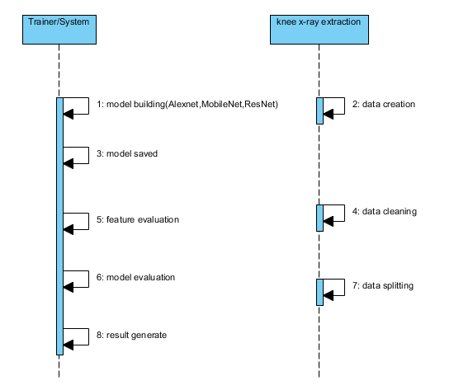

Collaboration Diagram:
In collaboration diagram the method call sequence is indicated by some numbering technique as shown below. The number indicates how the methods are called one after another. We have taken the same order management system to describe the collaboration diagram. The method calls are similar to that of a sequence diagram. But the difference is that the sequence diagram does not describe the object organization whereas the collaboration diagram shows the object organization.

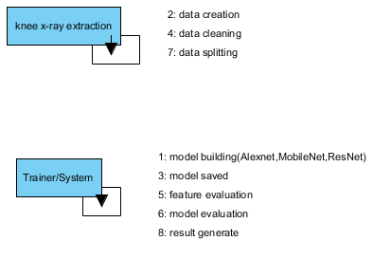
Deployment Diagram:
Deployment diagram represents the deployment view of a system. It is related to the component diagram. Because the components are deployed using the deployment diagrams. A deployment diagram consists of nodes. Nodes are nothing but physical hardware’s used to deploy the application.
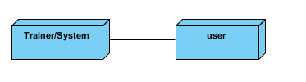

Activity Diagram:
Activity diagrams are graphical representations of workflows of stepwise activities and actions with support for choice, iteration and concurrency. In the Unified Modeling Language, activity diagrams can be used to describe the business and operational step-by-step workflows of components in a system. An activity diagram shows the overall flow of control.

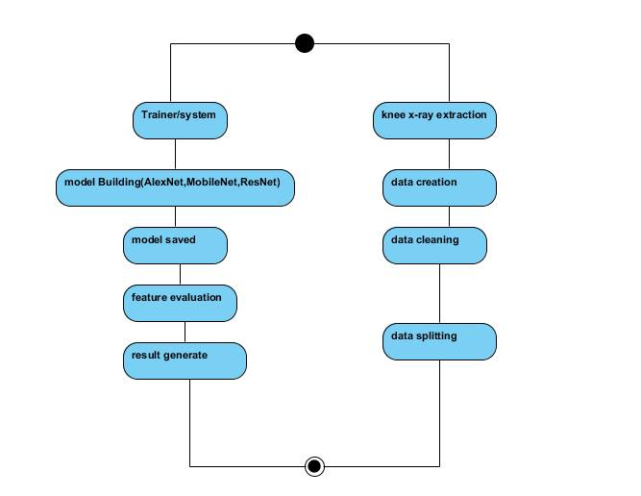

Component Diagram:
A component diagram, also known as a UML component diagram, describes the organization and wiring of the physical components in a system. Component diagrams are often drawn to help model implementation details and double-check that every aspect of the system's required function is covered by planned development.
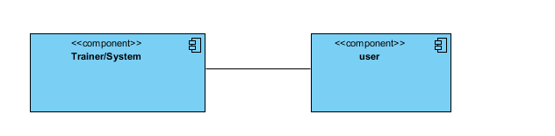
ER Diagram:
An Entity–relationship model (ER model) describes the structure of a database with the help of a diagram, which is known as Entity Relationship Diagram (ER Diagram). An ER model is a design or blueprint of a database that can later be implemented as a database. The main components of E-R model are: entity set and relationship set.
An ER diagram shows the relationship among entity sets. An entity set is a group of similar entities and these

entities can have attributes. In terms of DBMS, an entity is a table or attribute of a table in database, so by showing relationship among tables and their attributes, ER diagram shows the complete logical structure of a database. Let’s have a look at a simple ER diagram to understand this concept.

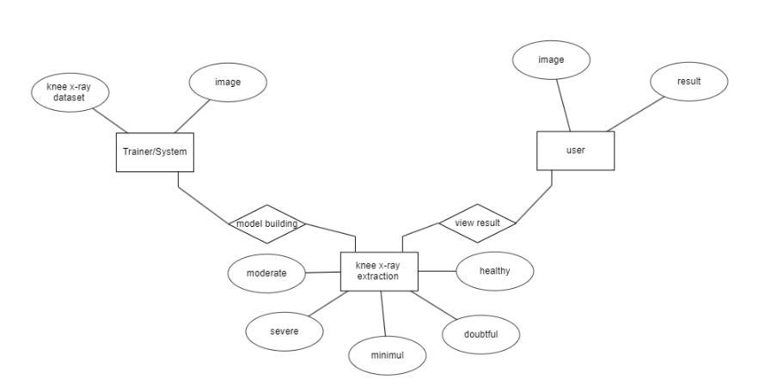

DFD Diagram:
A Data Flow Diagram (DFD) is a traditional way to visualize the information flows within a system. A neat and clear DFD can depict a good amount of the system requirements graphically. It can be manual, automated, or a combination of both. It shows how information enters and leaves the system, what changes the information and where information is stored. The purpose of a DFD is to show the scope and boundaries of a system as a whole. It may be used as a communications tool between a systems analyst and any person who plays a part in the system that acts as the starting point for redesigning a system.
Context level diagram:

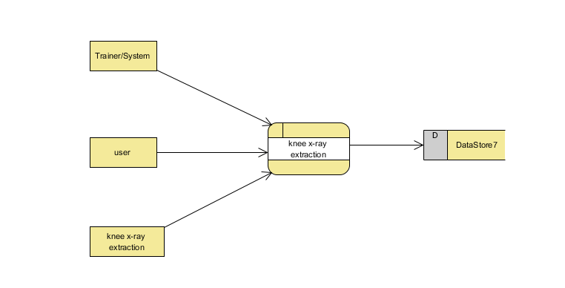
Level 1 diagram:

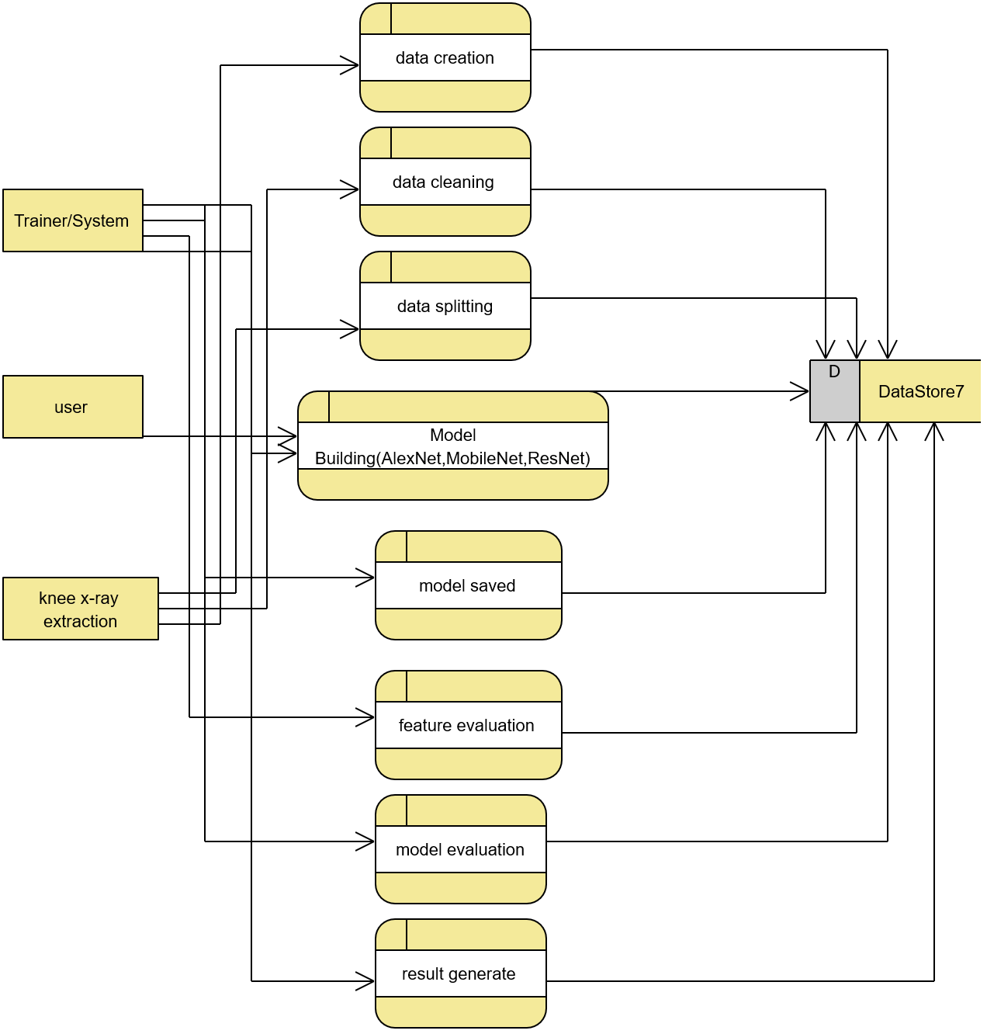
Level 2 diagram:

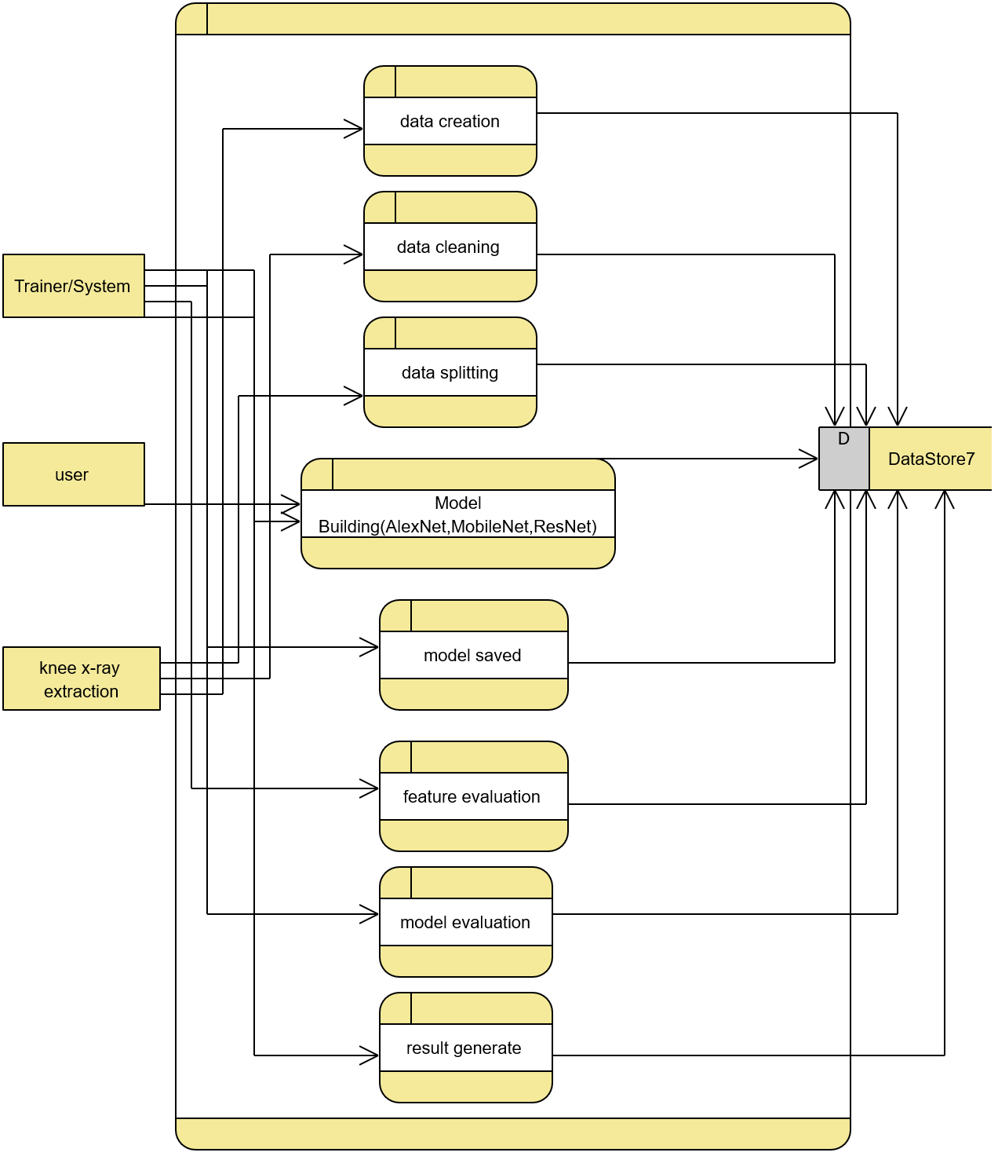

7. IMPLEMENTATION AND RESULTS
7.1 MODULES:
1. System:
1.1 Create Dataset:
The dataset containing images of chest x-ray images are to be classified is split into training and testing dataset with the test size of 30-20%.
1.2 Pre-processing:
Resizing and reshaping the images into appropriate format to train our model.
1.3 Training:
Use the pre-processed training dataset is used to train our model.
1.4 Classification:
The results of our model is display of images are with one of the given input images.
2. User:
2.1 user registration
User can register with the mentioned details like name, email, password, confirm password, contact number.
2.2 user login
In this page user can login with the email and password for further process
2.3 Upload Image
The user has to upload an image, which needs to be classified.
2.4 View Results
User views the classified image results.
  - logout
after complete the process user can logout from the process
7.2 OUTPUT SCREEN SHOTS WITH DESCRIPTION.
Home Page:
This is the home page of this application.
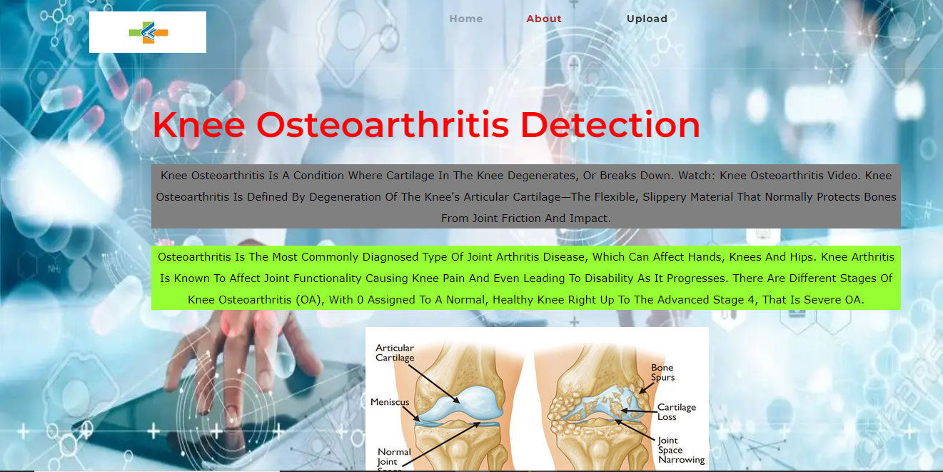
About Page:
This is the About page of this application.

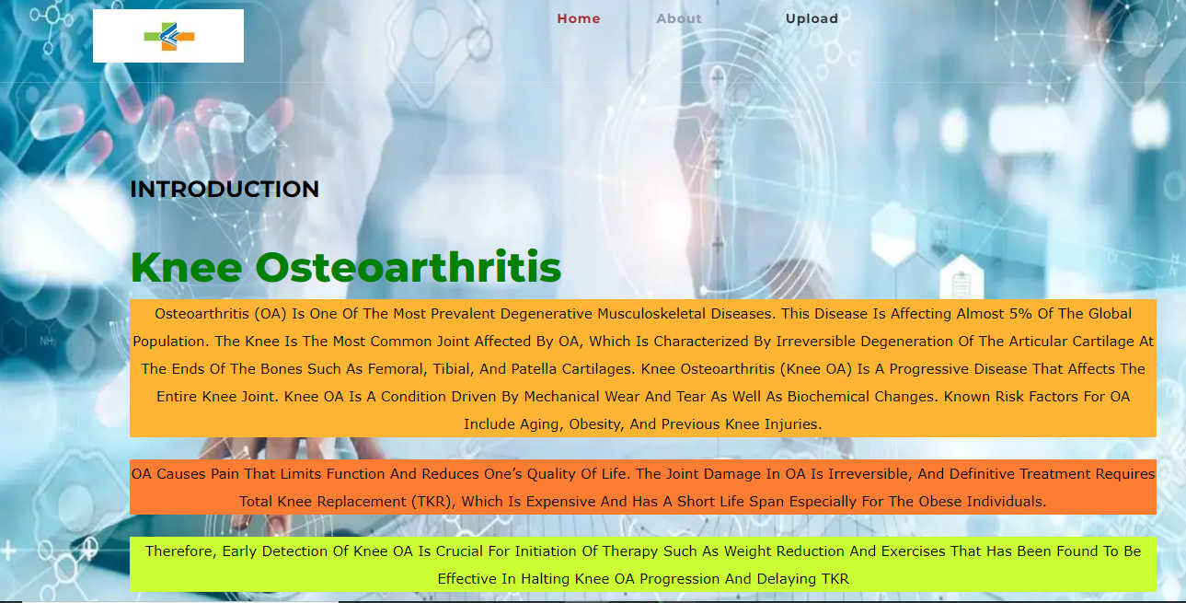
Upload Images:
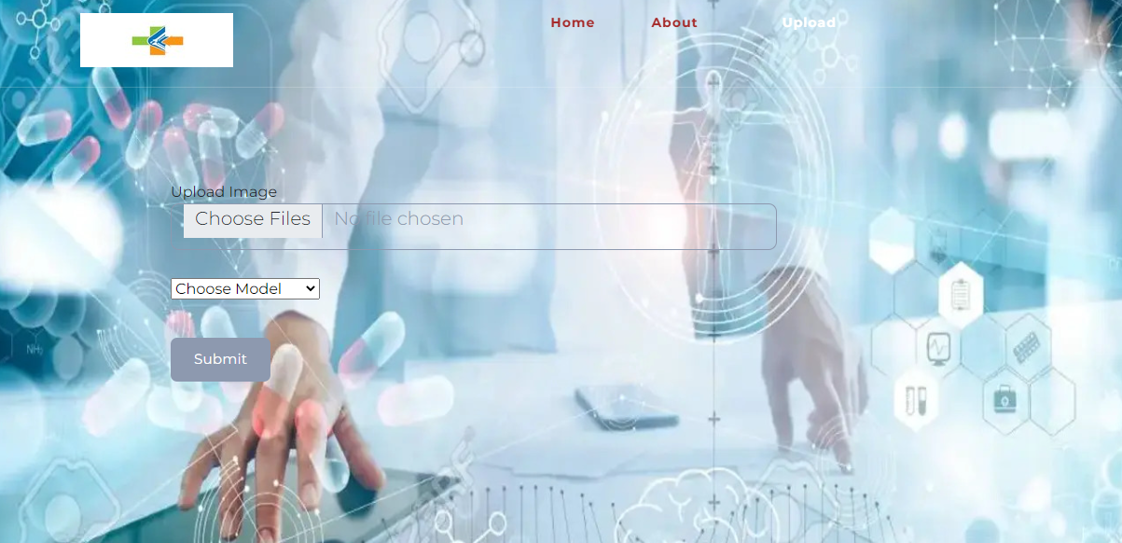

Healthy Image
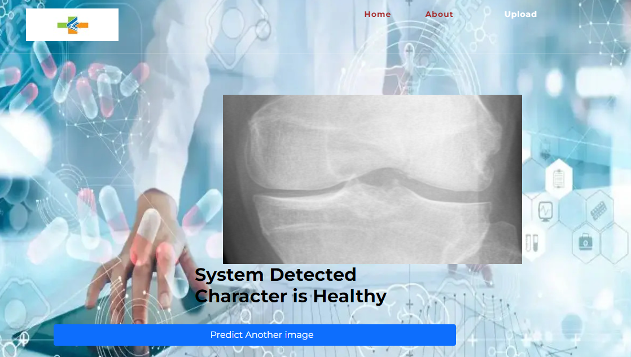

Doubtful Image
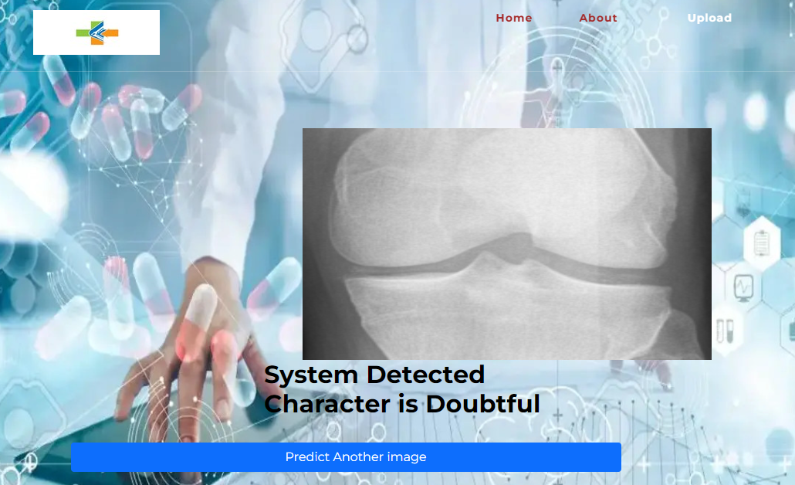

Minimal Image
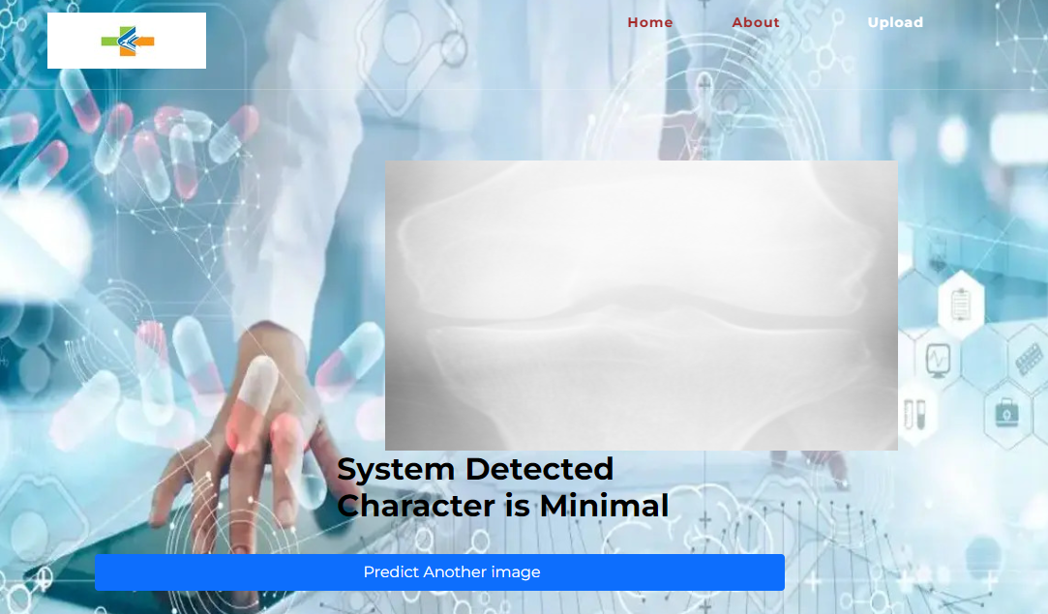
Moderate Image
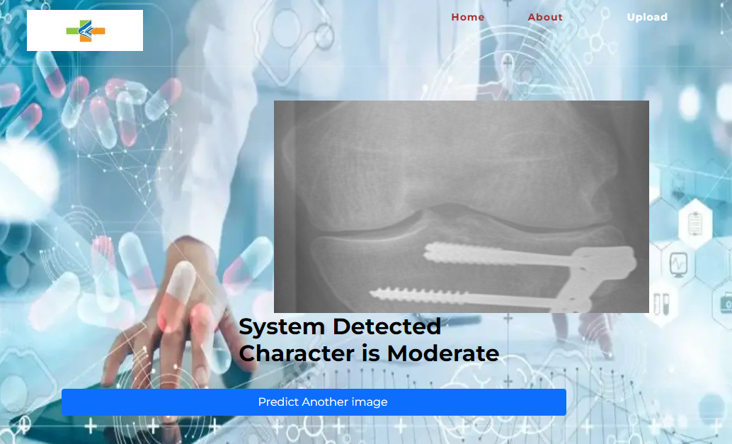

Severe Image
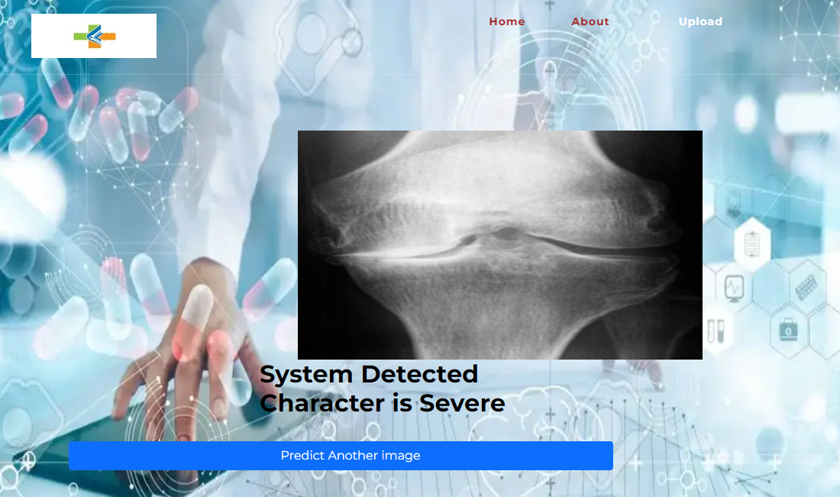

8. SYSTEM STUDY
8.1 Feasibility Study
The feasibility of the project is analysed in this phase and business proposal is put forth with a very general plan for the project and some cost estimates. During system analysis the feasibility study of the proposed system is to be carried out. This is to ensure that the proposed system is not a burden to the company. For feasibility analysis, some understanding of the major requirements for the system is essential.
Three key considerations involved in the feasibility analysis are
- Economic feasibility
- Technical feasibility
- Social feasibility
Economic Feasibility
This study is carried out to check the economic impact that the system will have on the organization. The amount of fund that the company can pour into the research and development of the system is limited. The expenditures must be justified. Thus the developed system as well within the budget and this was achieved because most of the technologies used are freely available. Only the customized products had to be purchased.

Technical Feasibility
This study is carried out to check the technical feasibility, that is, the technical requirements of the system. Any system developed must not have a high demand on the available technical resources. This will lead to high demands on the available technical resources. This will lead to high demands being placed on the client. The developed system must have a modest requirement, as only minimal or null changes are required for implementing this system.
Social Feasibility
The aspect of study is to check the level of acceptance of the system by the user. This includes the process of training the user to use the system efficiently. The user must not feel threatened by the system, instead must accept it as a necessity. The level of acceptance by the users solely depends on the methods that are employed to educate the user about the system and to make him familiar with it. His level of confidence must be raised so that he is also able to make some constructive criticism, which is welcomed, as he is the final user of the system.

System Testing
The purpose of testing is to discover errors. Testing is the process of trying to discover every conceivable fault or weakness in a work product. It provides a way to check the functionality of components, sub-assemblies, assemblies and/or a finished product It is the process of exercising software with the intent of ensuring that the
Software system meets its requirements and user expectations and does not fail in an unacceptable manner. There are various types of test. Each test type addresses a specific testing requirement.

8.2 Types of Tests

8.2.1 Unit testing
Unit testing involves the design of test cases that validate that the internal program logic is functioning properly, and that program inputs produce valid outputs. All decision branches and internal code flow should be validated. It is the testing of individual software units of the application .it is done after the completion of an individual unit before integration. This is a structural testing, that relies on knowledge of its construction and is invasive. Unit tests perform basic tests at component level and test a specific business process, application, and/or system configuration. Unit tests ensure that each unique path of a business process performs accurately to the documented specifications and contains clearly defined inputs and expected results.

8.2.2 Integration testing
Integration tests are designed to test integrated software components to determine if they actually run as one program. Testing is event driven and is more concerned with the basic outcome of screens or fields. Integration tests demonstrate that although the components were individually satisfaction, as shown by successfully unit testing, the combination of components is correct and consistent. Integration testing is specifically aimed at exposing the problems that arise from the combination of components.
Software integration testing is the incremental integration testing of two or more integrated software components on a single platform to produce failures caused by interface defects.
The task of the integration test is to check that components or software applications, e.g. components in a software system or – one step up – software applications at the company level – interact without error.
Test Results: All the test cases mentioned above passed successfully. No defects encountered.

Acceptance Testing
User Acceptance Testing is a critical phase of any project and requires significant participation by the end user. It also ensures that the system meets the functional requirements.
Test Results: All the test cases mentioned above passed successfully. No defects encountered.

8.2.3 Functional testing
Functional tests provide systematic demonstrations that functions tested are available as specified by the business and technical requirements, system documentation, and user manuals.
Functional testing is centered on the following items:
Valid Input : identified classes of valid input must be accepted.
Invalid Input : identified classes of invalid input must be rejected.
Functions : identified functions must be exercised.
Output : identified classes of application outputs must be exercised.
Systems/Procedures: interfacing systems or procedures must be invoked.
Organization and preparation of functional tests is focused on requirements, key functions, or special test cases. In addition, systematic coverage pertaining to identify Business process flows; data fields, predefined processes, and successive processes must be considered for testing. Before functional testing is complete, additional tests are identified and the effective value of current tests is determined.

8.2.4 White Box Testing
White Box Testing is a testing in which in which the software tester has knowledge of the inner workings, structure and language of the software, or at least its purpose. It is purpose. It is used to test areas that cannot be reached from a black box level.

8.2.5 Black Box Testing
Black Box Testing is testing the software without any knowledge of the inner workings, structure or language of the module being tested. Black box tests, as most other kinds of tests, must be written from a definitive source document, such as specification or requirements document, such as specification or requirements document. It is a testing in which the software under test is treated, as a black box. you cannot “see” into it. The test provides inputs and responds to outputs without considering how the software works.

Test objectives
- All field entries must work properly.
- Pages must be activated from the identified link.
- The entry screen, messages and responses must not be delayed.
Features to be tested
- Verify that the entries are of the correct format
- No duplicate entries should be allowed
- All links should take the user to the correct page.

9.CONCLUSION

In this project, we successfully developed an automated system to detect Knee Osteoarthritis from knee X-ray images using deep learning. The model uses Convolutional Neural Networks along with transfer learning to extract important features and classify the images into different severity levels such as Normal, Mild, Moderate, and Severe. Image preprocessing techniques were applied to improve data quality and model performance. The system achieved high accuracy and provides fast and reliable results. Overall, this project demonstrates how AI can assist doctors in early detection and improve decision-making in healthcare.

10.FUTURE SCOPE
This can be utilized in future to classify the types of different infections easily that which can tend to easy to find out the infections in early stages and can be cured in the initial stages only.

- REFERENCES

- Anifah, L., Purnomo, M., Mengko, T., Purnama, I.: Osteoarthritis severity determination using self organizing map based Gabor kernel. In: IOP Conference Series: Materials Science and Engineering, vol. 306, p. 012071. IOP Publishing (2018)
- Anifah, L., Purnama, I.K.E., Hariadi, M., Purnomo, M.H.: Osteoarthritis classification using self organizing map based on Gabor kernel and contrast-limited adaptive histogram equalization. Open Biomed. Eng. J. 7, 18 (2013)
- Antony, J., McGuinness, K., O’Connor, N.E., Moran, K.: Quantifying radiographic knee osteoarthritis severity using deep convolutional neural networks. In: 2016 23rd International Conference on Pattern Recognition (ICPR), pp. 1195–1200. IEEE (2016)
- He, K., Sun, J., Tang, X.: Guided image filtering. IEEE Trans. Pattern Anal. Mach. Intell. 6, 1397–1409 (2013)
- Hegadi, R.S., Kamble, P.M.: Recognition of Marathi handwritten numerals using multi-layer feed-forward neural network. In: 2014 World Congress on Computing and Communication Technologies (WCCCT), pp. 21–24. IEEE (2014)
- Hegadi, R.S., Navale, D.I., Pawar, T.D., Ruikar, D.D.: Multi feature-based classification of osteoarthritis in knee joint X-ray images. In: Medical Imaging: Artificial Intelligence, Image Recognition, and Machine Learning Techniques, chap. 5. CRC Press (2019). ISBN 9780367139612
- Hiremath, P.S., Dhandra, B.V., Hegadi, R., Rajput, G.G.: Abnormality detection in endoscopic images using color segmentation and curvature computation. In: Pal, N.R., Kasabov, N., Mudi, R.K., Pal, S., Parui, S.K. (eds.) ICONIP 2004. LNCS, vol. 3316, pp. 834–841. Springer, Heidelberg (2004). https://doi.org/10.1007/978- 3-540-30499-9 128
- Kawathekar, P.P., Karande, K.J.: Use of textural and statistical features for analyzing severity of radio-graphic osteoarthritis of knee joint. In: 2015 International Conference on Information Processing (ICIP), pp. 1–4. IEEE (2015)
- Mishra, M., Srivastava, M.: A view of artificial neural network. In: 2014 International Conference on
- Advances in Engineering and Technology Research (ICAETR), pp. 1–3. IEEE (2014)
- Navale, D.I., Hegadi, R.S., Mendgudli, N.: Block based texture analysis approach for knee osteoarthritis identification using SVM. In: 2015 IEEE International WIE Conference on Electrical and Computer Engineering (WIECON-ECE), pp. 338– 341. IEEE (2015)
- Raj, A., Vishwanathan, S., Ajani, B., Krishnan, K., Agarwal, H.: Automatic knee cartilage segmentation using fully volumetric convolutional neural networks for evaluation of osteoarthritis. In: 2018 IEEE 15th International Symposium on Biomedical Imaging (ISBI 2018), pp. 851–854. IEEE (2018)
- Ruikar, D.D., Hegadi, R.S., Santosh, K.: A systematic review on orthopedic simulators for psycho-motor skill and surgical procedure training. J. Med. Syst. 42(9), 168 (2018)
- Ruikar, D.D., Santosh, K.C., Hegadi, R.S.: Automated fractured bone segmentation and labeling from CT images. J. Med. Syst. 43(3), 60 (2019). https://doi.org/ 10.1007/s10916-019-1176-x
- Ruikar, D.D., Santosh, K.C., Hegadi, R.S.: Segmentation and analysis of CT images for bone fracture detection and labeling. In: Medical Imaging: Artificial Intelligence, Image Recognition, and Machine Learning Techniques, chap. 7. CRC Press (2019). ISBN 9780367139612

BIBLIOGRAPHY:
SOFTWARE INSTALLATION FOR MACHINE LEARNING PROJECTS:
Installing Python:
- To download and install Python visit the official website of Python https://www.python.org/downloads/ and choose your version.
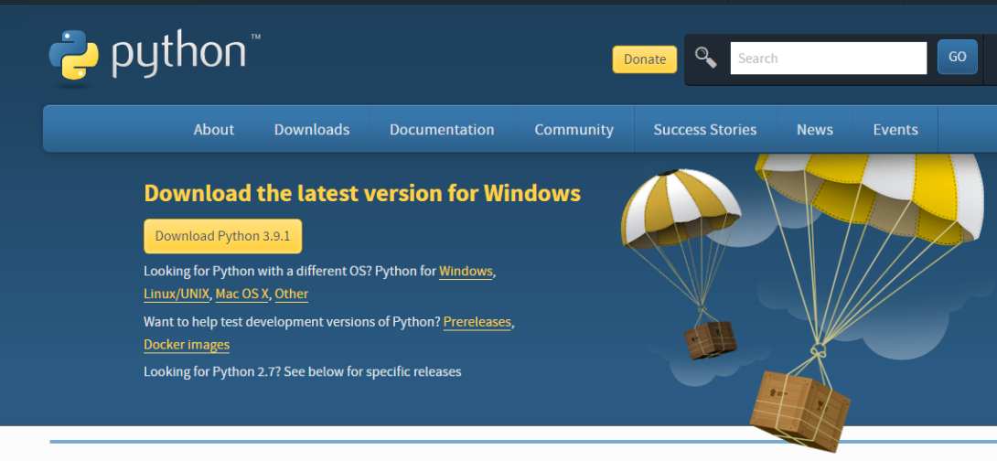
- Once the download is complete, run the exe for install Python. Now click on Install Now.
- You can see Python installing at this point.
- When it finishes, you can see a screen that says the Setup was successful. Now click on "Close".
Installing PyCharm:
- To download PyCharm visit the website https://www.jetbrains.com/pycharm/download/ and click the "DOWNLOAD" link under the Community Section.


- Once the download is complete, run the exe for install PyCharm. The setup wizard should have started. Click “Next”.
- On the next screen, Change the installation path if required. Click “Next”.
- On the next screen, you can create a desktop shortcut if you want and click on “Next”.
- Choose the start menu folder. Keep selected Jet Brains and click on “Install”.
- Wait for the installation to finish.
- Once installation finished, you should receive a message screen that PyCharm is installed. If you want to go ahead and run it, click the “Run PyCharm Community Edition” box first and click “Finish”.
- After you click on "Finish," the Following screen will appear.
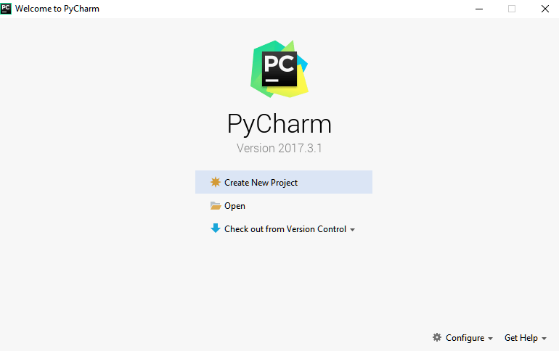
9. You need to install some packages to execute your project in a proper way.
10. Open the command prompt/ anaconda prompt or terminal as administrator.
11. The prompt will get open, with specified path, type “pip install package name” which you want to install (like NumPy, pandas, sea born, scikit-learn, Matplotlib, Pyplot)
Ex: Pip install NumPy

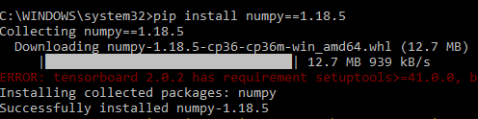

INTRODUCTION TO PYTHON
- Python

What Is a Script?
Up to this point, I have concentrated on the interactive programming capability of Python. This is a very useful capability that allows you to type in a program and to have it executed immediately in an interactive mode
Scripts are reusable
Basically, a script is a text file containing the statements that comprise a Python program. Once you have created the script, you can execute it over and over without having to retype it each time.
Scripts are editable
Perhaps, more importantly, you can make different versions of the script by modifying the statements from one file to the next using a text editor. Then you can execute each of the individual versions. In this way, it is easy to create different programs with a minimum amount of typing.
You will need a text editor
Just about any text editor will suffice for creating Python script files.
You can use Microsoft Notepad, Microsoft WordPad, Microsoft Word, or just about any word processor if you want to.
Difference between a script and a program
Script:
Scripts are distinct from the core code of the application, which is usually written in a different language, and are often created or at least modified by the end-user. Scripts are often interpreted from source code or byte code, whereas the applications they control are traditionally compiled to native machine code.
Program:
The program has an executable form that the computer can use directly to execute the instructions.
The same program in its human-readable source code form, from which executable programs are derived (e.g., compiled)
Python
What is Python? Chances you are asking yourself this. You may have found this book because you want to learn to program but don’t know anything about programming languages. Or you may have heard of programming languages like C, C++, C#, or Java and want to know what Python is and how it compares to “big name” languages. Hopefully I can explain it for you.
Python concepts
If you’re not interested in the how’s and whys of Python, feel free to skip to the next chapter. In this chapter I will try to explain to the reader why I think Python is one of the best languages available and why it’s a great one to start programming with.

• Open-source general-purpose language.
• Object Oriented, Procedural, Functional
• Easy to interface with C/ObjC/Java/Fortran
• Easy-is to interface with C++ (via SWIG)
• Great interactive environment
• Great interactive environment
Python is a high-level, interpreted, interactive and object-oriented scripting language. Python is designed to be highly readable. It uses English keywords frequently where as other languages use punctuation, and it has fewer syntactical constructions than other languages.
- Python is Interpreted − Python is processed at runtime by the interpreter. You do not need to compile your program before executing it. This is similar to PERL and PHP.
- Python is Interactive − you can actually sit at a Python prompt and interact with the interpreter directly to write your programs.
- Python is Object-Oriented − Python supports Object-Oriented style or technique of programming that encapsulates code within objects.
- Python is a Beginner's Language − Python is a great language for the beginner-level programmers and supports the development of a wide range of applications from simple text processing to WWW browsers to games.

History of Python
Python was developed by Guido van Possum in the late eighties and early nineties at the National Research Institute for Mathematics and Computer Science in the Netherlands.
Python is derived from many other languages, including ABC, Modula-3, C, C++, Algol-68, Smalltalk, and UNIX shell and other scripting languages.
Python is copyrighted. Like Perl, Python source code is now available under the GNU General Public License (GPL).
Python is now maintained by a core development team at the institute, although Guido van Possum still holds a vital role in directing its progress.

Python Features
Python's features include −
- Easy-to-learn − Python has few keywords, simple structure, and a clearly defined syntax. This allows the student to pick up the language quickly.
- Easy-to-read − Python code is more clearly defined and visible to the eyes.
- Easy-to-maintain − Python's source code is fairly easy-to-maintained.
- A broad standard library − Python's bulk of the library is very portable and cross-platform compatible on UNIX, Windows, and Macintosh.

- Interactive Mode − Python has support for an interactive mode which allows interactive testing and debugging of snippets of code.
- Portable − Python can run on a wide variety of hardware platforms and has the same interface on all platforms.
- Extendable − you can add low-level modules to the Python interpreter. These modules enable programmers to add to or customize their tools to be more efficient.
- Databases − Python provides interfaces to all major commercial databases.
- GUI Programming − Python supports GUI applications that can be created and ported to many system calls, libraries and windows systems, such as Windows MFC, Macintosh, and the X Window system of Unix.
- Scalable − Python provides a better structure and support for large programs than shell scripting.

Apart from the above-mentioned features, Python has a big list of good features, few are listed below −
- It supports functional and structured programming methods as well as OOP.
- It can be used as a scripting language or can be compiled to byte-code for building large applications.
- It provides very high-level dynamic data types and supports dynamic type checking.
- IT supports automatic garbage collection.
- It can be easily integrated with C, C++, COM, ActiveX, CORBA, and Java.

Dynamic vs. Static
Types Python is a dynamic-typed language. Many other languages are static typed, such as C/C++ and Java. A static typed language requires the programmer to explicitly tell the computer what type of “thing” each data value is.
For example, in C if you had a variable that was to contain the price of something, you would have to declare the variable as a “float” type.
This tells the compiler that the only data that can be used for that variable must be a floating point number, i.e. a number with a decimal point.
If any other data value was assigned to that variable, the compiler would give an error when trying to compile the program.
Python, however, doesn’t require this. You simply give your variables names and assign values to them. The interpreter takes care of keeping track of what kinds of objects your program is using. This also means that you can change the size of the values as you develop the program. Say you have another decimal number (a.k.a. a floating point number) you need in your program.
With a static typed language, you have to decide the memory size the variable can take when you first initialize that variable. A double is a floating point value that can handle a much larger number than a normal float (the actual memory sizes depend on the operating environment).

If you declare a variable to be a float but later on assign a value that is too big to it, your program will fail; you will have to go back and change that variable to be a double.

With Python, it doesn’t matter. You simply give it whatever number you want and Python will take care of manipulating it as needed. It even works for derived values.
For example, say you are dividing two numbers. One is a floating point number and one is an integer. Python realizes that it’s more accurate to keep track of decimals so it automatically calculates the result as a floating point number
Variables
Variables are nothing but reserved memory locations to store values. This means that when you create a variable you reserve some space in memory.
Based on the data type of a variable, the interpreter allocates memory and decides what can be stored in the reserved memory. Therefore, by assigning different data types to variables, you can store integers, decimals or characters in these variables.

Standard Data Types
The data stored in memory can be of many types. For example, a person's age is stored as a numeric value and his or her address is stored as alphanumeric characters. Python has various standard data types that are used to define the operations possible on them and the storage method for each of them.
Python has five standard data types −
- Numbers
- String
- List
- Tuple
- Dictionary

Python Numbers
Number data types store numeric values. Number objects are created when you assign a value to them

Python Strings

Strings in Python are identified as a contiguous set of characters represented in the quotation marks. Python allows for either pairs of single or double quotes. Subsets of strings can be taken using the slice operator ([ ] and [:]) with indexes starting at 0 in the beginning of the string and working their way from -1 at the end.

Python Lists

Lists are the most versatile of Python's compound data types. A list contains items separated by commas and enclosed within square brackets ([]). To some extent, lists are similar to arrays in C. One difference between them is that all the items belonging to a list can be of different data type.
The values stored in a list can be accessed using the slice operator ([ ] and [:]) with indexes starting at 0 in the beginning of the list and working their way to end -1. The plus (+) sign is the list concatenation operator, and the asterisk (*) is the repetition operator.

Python Tuples
A tuple is another sequence data type that is similar to the list. A tuple consists of a number of values separated by commas. Unlike lists, however, tuples are enclosed within parentheses.
The main differences between lists and tuples are: Lists are enclosed in brackets ([ ]) and their elements and size can be changed, while tuples are enclosed in parentheses (( )) and cannot be updated. Tuples can be thought of as read-only lists.

Python Dictionary
Python's dictionaries are kind of hash table type. They work like associative arrays or hashes found in Perl and consist of key-value pairs. A dictionary key can be almost any Python type, but are usually numbers or strings. Values, on the other hand, can be any arbitrary Python object.
Dictionaries are enclosed by curly braces ({ }) and values can be assigned and accessed using square braces ([]).

Different modes in python
Python has two basic modes: normal and interactive.
The normal mode is the mode where the scripted and finished .pie files are run in the Python interpreter.
Interactive mode is a command line shell which gives immediate feedback for each statement, while running previously fed statements in active memory. As new lines are fed into the interpreter, the fed program is evaluated both in part and in whole

20 Python libraries
1. Requests. The most famous http library written by Kenneth remits. It’s a must have for every python developer.
2. Scrappy. If you are involved in web scraping then this is a must have library for you. After using this library you won’t use any other.
3. Python. A guy toolkit for python. I have primarily used it in place of tinder. You will really love it.
4. Pillow. A friendly fork of PIL (Python Imaging Library). It is more user friendly than PIL and is a must have for anyone who works with images.
5. SQL Alchemy. A database library. Many love it and many hate it. The choice is yours.
6. Beautiful Soup. I know it’s slow but this xml and html parsing library is very useful for beginners.
7. Twisted. The most important tool for any network application developer. It has a very beautiful ape and is used by a lot of famous python developers.
8. Numbly. How can we leave this very important library? It provides some advance math functionalities to python.
9. Skippy. When we talk about numbly then we have to talk about spicy. It is a library of algorithms and mathematical tools for python and has caused many scientists to switch from ruby to python.
10. Matplotlib. A numerical plotting library. It is very useful for any data scientist or any data analyzer.
11. Pygmy. Which developer does not like to play games and develop them? This library will help you achieve your goal of 2d game development.
12. Piglet. A 3d animation and game creation engine. This is the engine in which the famous python port of mine craft was made
13. Pit. A GUI toolkit for python. It is my second choice after python for developing GUI’s for my python scripts.
14. Pit. Another python GUI library. It is the same library in which the famous Bit torrent client is created.
15. Scaly. A packet sniffer and analyzer for python made in python.
16. Pywin32. A python library which provides some useful methods and classes for interacting with windows.
17. Notch. Natural Language Toolkit – I realize most people won’t be using this one, but it’s generic enough. It is a very useful library if you want to manipulate strings. But its capacity is beyond that. Do check it out.
18. Nose. A testing framework for python. It is used by millions of python developers. It is a must have if you do test driven development.
19. Simply. Simply can do algebraic evaluation, differentiation, expansion, complex numbers, etc. It is contained in a pure Python distribution.
20. I Python. I just can’t stress enough how useful this tool is. It is a python prompt on steroids. It has completion, history, shell capabilities, and a lot more. Make sure that you take a look at it.
Numpy
Humpy’s main object is the homogeneous multidimensional array. It is a table of elements (usually numbers), all of the same type, indexed by a tuple of positive integers. In numbly dimensions are called axes. The number of axes is rank.
• Offers Matlab-ish capabilities within Python
• Fast array operations
• 2D arrays, multi-D arrays, linear algebra etc.
Matplotlib
• High quality plotting library.

Python class and objects
These are the building blocks of OOP. Class creates a new object. This object can be anything, whether an abstract data concept or a model of a physical object, e.g. a chair. Each class has individual characteristics

unique to that class, including variables and methods. Classes are very powerful and currently “the big thing” in most programming languages. Hence, there are several chapters dedicated to OOP later in the book.
The class is the most basic component of object-oriented programming. Previously, you learned how to use functions to make your program do something.
Now will move into the big, scary world of Object-Oriented Programming (OOP). To be honest, it took me several months to get a handle on objects.
When I first learned C and C++, I did great; functions just made sense for me.
Having messed around with BASIC in the early ’90s, I realized functions were just like subroutines so there wasn’t much new to learn.
However, when my C++ course started talking about objects, classes, and all the new features of OOP, my grades definitely suffered.
Once you learn OOP, you’ll realize that it’s actually a pretty powerful tool. Plus many Python libraries and APIs use classes, so you should at least be able to understand what the code is doing.
One thing to note about Python and OOP: it’s not mandatory to use objects in your code in a way that works best; maybe you don’t need to have a full-blown class with initialization code and methods to just return a calculation. With Python, you can get as technical as you want.
As you’ve already seen, Python can do just fine with functions. Unlike languages such as Java, you aren’t tied down to a single way of doing things; you can mix functions and classes as necessary in the same program. This lets you build the code
Objects are an encapsulation of variables and functions into a single entity. Objects get their variables and functions from classes. Classes are essentially a template to create your objects.
Here’s a brief list of Python OOP ideas:
• The class statement creates a class object and gives it a name. This creates a new namespace.
• Assignments within the class create class attributes. These attributes are accessed by qualifying the name using dot syntax: ClassName.Attribute.
• Class attributes export the state of an object and its associated behavior. These attributes are shared by all instances of a class.
• Calling a class (just like a function) creates a new instance of the class.
This is where the multiple copies part comes in.
• Each instance gets ("inherits") the default class attributes and gets its own namespace. This prevents instance objects from overlapping and confusing the program.
• Using the term self identifies a particular instance, allowing for per-instance attributes. This allows items

such as variables to be associated with a particular instance.
Inheritance
First off, classes allow you to modify a program without really making changes to it.
To elaborate, by sub classing a class, you can change the behaviour of the program by simply adding new components to it rather than rewriting the existing components.

As we’ve seen, an instance of a class inherits the attributes of that class.
However, classes can also inherit attributes from other classes. Hence, a subclass inherits from a superclass allowing you to make a generic superclass that is specialized via subclasses.
The subclasses can override the logic in a superclass, allowing you to change the behavior of your classes without changing the superclass at all.
Operator Overloads
Operator overloading simply means that objects that you create from classes can respond to actions (operations) that are already defined within Python, such as addition, slicing, printing, etc.
Even though these actions can be implemented via class methods, using overloading ties the behavior closer to Python’s object model and the object interfaces are more consistent to Python’s built-in objects, hence overloading is easier to learn and use.
User-made classes can override nearly all of Python’s built-in operation methods
Exceptions
I’ve talked about exceptions before but now I will talk about them in depth. Essentially, exceptions are events that modify program’s flow, either intentionally or due to errors.
They are special events that can occur due to an error, e.g. trying to open a file that doesn’t exist, or when the program reaches a marker, such as the completion of a loop.
Exceptions, by definition, don’t occur very often; hence, they are the "exception to the rule" and a special class has been created for them. Exceptions are everywhere in Python.
Virtually every module in the standard Python library uses them, and Python itself will raise them in a lot of different circumstances.
Here are just a few examples:
• Accessing a non−existent dictionary key will raise a Key Error exception.
• Searching a list for a non−existent value will raise a Value Error exception
. • Calling a non−existent method will raise an Attribute Error exception.
• Referencing a non−existent variable will raise a Name Error exception.
• Mixing data types without coercion will raise a Type Error exception.
One use of exceptions is to catch a fault and allow the program to continue working; we have seen this before when we talked about files.
This is the most common way to use exceptions. When programming with the Python command line

interpreter, you don’t need to worry about catching exceptions.
Your program is usually short enough to not be hurt too much if an exception occurs.
Plus, having the exception occur at the command line is a quick and easy way to tell if your code logic has a problem.
However, if the same error occurred in your real program, it will fail and stop working. Exceptions can be created manually in the code by raising an exception.
It operates exactly as a system-caused exceptions, except that the programmer is doing it on purpose.

This can be for a number of reasons. One of the benefits of using exceptions is that, by their nature, they don’t put any overhead on the code processing.
Because exceptions aren’t supposed to happen very often, they aren’t processed until they occur.
Exceptions can be thought of as a special form of the if/elf statements. You can realistically do the same thing with if blocks as you can with exceptions.
However, as already mentioned, exceptions aren’t processed until they occur; if blocks are processed all the time.
Proper use of exceptions can help the performance of your program.
The more infrequent the error might occur, the better off you are to use exceptions; using if blocks requires Python to always test extra conditions before continuing.
Exceptions also make code management easier: if your programming logic is mixed in with error-handling if statements, it can be difficult to read, modify, and debug your program.
User-Defined Exceptions
I won’t spend too much time talking about this, but Python does allow for a programmer to create his own exceptions.
You probably won’t have to do this very often but it’s nice to have the option when necessary.
However, before making your own exceptions, make sure there isn’t one of the built-in exceptions that will work for you.
They have been "tested by fire" over the years and not only work effectively, they have been optimized for performance and are bug-free.
Making your own exceptions involves object-oriented programming, which will be covered in the next chapter
. To make a custom exception, the programmer determines which base exception to use as the class to inherit from, e.g. making an exception for negative numbers or one for imaginary numbers would probably fall under the Arithmetic Error exception class.
To make a custom exception, simply inherit the base exception and define what it will do.
Python modules
Python allows us to store our code in files (also called modules). This is very useful for more serious

programming, where we do not want to retype a long function definition from the very beginning just to change one mistake. In doing this, we are essentially defining our own modules, just like the modules defined already in the Python library.
To support this, Python has a way to put definitions in a file and use them in a script or in an interactive instance of the interpreter. Such a file is called a module; definitions from a module can be imported into other modules or into the main module.
Testing code
As indicated above, code is usually developed in a file using an editor.
To test the code, import it into a Python session and try to run it.

Usually there is an error, so you go back to the file, make a correction, and test again.
This process is repeated until you are satisfied that the code works. T
His entire process is known as the development cycle.
There are two types of errors that you will encounter. Syntax errors occur when the form of some command is invalid.
This happens when you make typing errors such as misspellings, or call something by the wrong name, and for many other reasons. Python will always give an error message for a syntax error.
Functions in Python
It is possible, and very useful, to define our own functions in Python. Generally speaking, if you need to do a calculation only once, then use the interpreter. But when you or others have need to perform a certain type of calculation many times, then define a function.
You use functions in programming to bundle a set of instructions that you want to use repeatedly or that, because of their complexity, are better self-contained in a sub-program and called when needed. That means that a function is a piece of code written to carry out a specified task.

To carry out that specific task, the function might or might not need multiple inputs. When the task is carved out, the function can or cannot return one or more values.

There are three types of functions in python:

Help (), min (), print ().
Namespaces in Python are implemented as Python dictionaries, this means it is a mapping from names (keys) to objects (values). The user doesn't have to know this to write a Python program and when using namespaces.
Some namespaces in Python:
- global names of a module
- local names in a function or method invocation
- built-in names: this namespace contains built-in functions (e.g. abs(), camp(), ...) and built-in exception names
Garbage Collection
Garbage Collector exposes the underlying memory management mechanism of Python, the automatic garbage collector. The module includes functions for controlling how the collector operates and to examine the objects known to the system, either pending collection or stuck in reference cycles and unable to be freed.
Python XML Parser
XML is a portable, open source language that allows programmers to develop applications that can be read by other applications, regardless of operating system and/or developmental language.
What is XML? The Extensible Markup Language XML is a markup language much like HTML or SGML.
This is recommended by the World Wide Web Consortium and available as an open standard.
XML is extremely useful for keeping track of small to medium amounts of data without requiring a SQL-based backbone.
XML Parser Architectures and APIs the Python standard library provides a minimal but useful set of interfaces to work with XML.
The two most basic and broadly used APIs to XML data are the SAX and DOM interfaces.
Simple API for XML SAX: Here, you register call-backs for events of interest and then let the parser proceed through the document.
This is useful when your documents are large or you have memory limitations, it parses the file as it reads it from disk and the entire file is never stored in memory.
Document Object Model DOM API : This is a World Wide Web Consortium recommendation wherein the entire file is read into memory and stored in a hierarchical tree − based form to represent all the features of an XML document.
SAX obviously cannot process information as fast as DOM can when working with large files. On the other hand, using DOM exclusively can really kill your resources, especially if used on a lot of small files.
SAX is read-only, while DOM allows changes to the XML file. Since these two different APIs literally complement each other, there is no reason why you cannot use them both for large projects.
Python Web Frameworks
A web framework is a code library that makes a developer's life easier when building reliable, scalable and maintainable web applications.

Why are web frameworks useful?
Web frameworks encapsulate what developers have learned over the past twenty years while programming sites and applications for the web. Frameworks make it easier to reuse code for common HTTP operations and to structure projects so other developers with knowledge of the framework can quickly build and maintain the application.

Common web framework functionality
Frameworks provide functionality in their code or through extensions to perform common operations required to run web applications. These common operations include:

- URL routing
- HTML, XML, JSON, and other output format tinplating
- Database manipulation
- Security against Cross-site request forgery (CSRF) and other attacks
- Session storage and retrieval
Not all web frameworks include code for all of the above functionality. Frameworks fall on the spectrum from executing a single use case to providing every known web framework feature to every developer. Some frameworks take the "batteries-included" approach where everything possible comes bundled with the framework while others have a minimal core package that is amenable to extensions provided by other packages.

Comparing web frameworks
There is also a repository called compare-python-web-frameworks where the same web application is being coded with varying Python web frameworks, tinplating engines and object.

Web framework resources
- When you are learning how to use one or more web frameworks it's helpful to have an idea of what the code under the covers is doing.
- Frameworks is a really well done short video that explains how to choose between web frameworks. The author has some particular opinions about what should be in a framework. For the most part I agree although I've found sessions and database ORMs to be a helpful part of a framework when done well.
- What is a web framework? Is an in-depth explanation of what web frameworks are and their relation to web servers?
- Jingo vs. Flash vs. Pyramid: Choosing a Python web framework contains background information and code comparisons for similar web applications built in these three big Python frameworks.
- This fascinating blog post takes a look at the code complexity of several Python web frameworks by providing visualizations based on their code bases.
- Python’s web frameworks benchmarks is a test of the responsiveness of a framework with encoding an object to JSON and returning it as a response as well as retrieving data from the database and rendering it in a template. There were no conclusive results but the output is fun to read about nonetheless.
- What web frameworks do you use and why are they awesome? Is a language agnostic Reedit discussion on web frameworks? It's interesting to see what programmers in other languages like and dislike about their suite of web frameworks compared to the main Python frameworks.
- This user-voted question & answer site asked "What are the best general purpose Python web frameworks usable in production?” The votes aren't as important as the list of the many frameworks that are available to Python developers.

Web frameworks learning checklist
- Choose a major Python web framework (Jingo or Flask are recommended) and stick with it. When you're just starting it's best to learn one framework first instead of bouncing around trying to understand every framework.
- Work through a detailed tutorial found within the resources links on the framework's page.
- Study open source examples built with your framework of choice so you can take parts of those projects and reuse the code in your application.
- Build the first simple iteration of your web application then go to the deployment section to make it accessible on the web.
2. SYSTEM STUDY

SYSTEM TESTING
The purpose of testing is to discover errors. Testing is the process of trying to discover every conceivable fault or weakness in a work product. It provides a way to check the functionality of components, sub-assemblies, assemblies and/or a finished product It is the process of exercising software with the intent of ensuring that the
Software system meets its requirements and user expectations and does not fail in an unacceptable manner. There are various types of test. Each test type addresses a specific testing requirement.

TYPES OF TESTS

Unit testing
Unit testing involves the design of test cases that validate that the internal program logic is functioning properly, and that program inputs produce valid outputs. All decision branches and internal code flow should be validated. It is the testing of individual software units of the application .it is done after the completion of an individual unit before integration. This is a structural testing, that relies on knowledge of its construction and is invasive. Unit tests perform basic tests at component level and test a specific business process, application, and/or system configuration. Unit tests ensure that each unique path of a business process performs accurately to the documented specifications and contains clearly defined inputs and expected results.

Integration testing
Integration tests are designed to test integrated software components to determine if they actually run as one program. Testing is event driven and is more concerned with the basic outcome of screens or fields. Integration tests demonstrate that although the components were individually satisfaction, as shown by successfully unit testing, the combination of components is correct and consistent. Integration testing is specifically aimed at exposing the problems that arise from the combination of components.

Functional test
Functional tests provide systematic demonstrations that functions tested are available as specified by the business and technical requirements, system documentation, and user manuals.
Functional testing is centered on the following items:
Valid Input : identified classes of valid input must be accepted.
Invalid Input : identified classes of invalid input must be rejected.
Functions : identified functions must be exercised.
Output : identified classes of application outputs must be exercised.
Systems/Procedures: interfacing systems or procedures must be invoked.
Organization and preparation of functional tests is focused on requirements, key functions, or special test cases. In addition, systematic coverage pertaining to identify Business process flows; data fields, predefined processes, and successive processes must be considered for testing. Before functional testing is complete.

SYSTEM TEST
System testing ensures that the entire integrated software system meets requirements. It tests a configuration to ensure known and predictable results. An example of system testing is the configuration oriented system integration test. System testing is based on process descriptions and flows, emphasizing pre-driven process links and integration points.

White Box Testing
White Box Testing is a testing in which in which the software tester has knowledge of the inner workings, structure and language of the software, or at least its purpose. It is purpose. It is used to test areas that cannot be reached from a black box level.

Black Box Testing
Black Box Testing is testing the software without any knowledge of the inner workings, structure or language of the module being tested. Black box tests, as most other kinds of tests, must be written from a definitive source document, such as specification or requirements document, such as specification or requirements document. It is a testing in which the software under test is treated, as a black box .you cannot “see” into it. The test provides inputs and responds to outputs without considering how the software works.

6.1 Unit Testing:
Unit testing is usually conducted as part of a combined code and unit test phase of the software lifecycle, although it is not uncommon for coding and unit testing to be conducted as two distinct phases.

Test strategy and approach
Field testing will be performed manually and functional tests will be written in detail.
Test objectives
- All field entries must work properly.
- Pages must be activated from the identified link.
- The entry screen, messages and responses must not be delayed.
Features to be tested
- Verify that the entries are of the correct format
- No duplicate entries should be allowed
- All links should take the user to the correct page.

6.2 Integration Testing
Software integration testing is the incremental integration testing of two or more integrated software components on a single platform to produce failures caused by interface defects.
The task of the integration test is to check that components or software applications, e.g. components in a software system or – one step up – software applications at the company level – interact without error.
Test Results: All the test cases mentioned above passed successfully. No defects encountered.

6.3 Acceptance Testing
User Acceptance Testing is a critical phase of any project and requires significant participation by the end user. It also ensures that the system meets the functional requirements.
Test Results: All the test cases mentioned above passed successfully. No defects encountered.

APPENDIX
CODE:
App.py
from flask import Flask, url_for, redirect, render_template, request, session,flash,send_from_directory
import pymysql
import os
import pandas as pd
import joblib
from PIL import Image
import matplotlib.pyplot as plt
import numpy as np
# from tensorflow.keras.models import load_model
# from tensorflow.keras.preprocessing import image
from scipy.sparse import csr_matrix
from scipy.sparse.linalg import svds
import torch
import torch.nn as nn
import torchvision.transforms as transforms
from torchvision import models
from PIL import Image
class EnsembleModel(nn.Module):
def __init__(self, num_classes):
super(EnsembleModel, self).__init__()
self.resnet50 = models.resnet50(pretrained=True)
self.resnet50.fc = nn.Identity() # Output: 2048 features

self.mobilenetv2 = models.mobilenet_v2(pretrained=True)
self.mobilenetv2.classifier[1] = nn.Identity() # Output: 1280 features

self.alexnet = models.alexnet(pretrained=True)
self.alexnet.classifier[6] = nn.Identity() # Output: 4096 features

# Freeze the pre-trained model parameters
for param in self.resnet50.parameters():
param.requires_grad = False
for param in self.mobilenetv2.parameters():

param.requires_grad = False
for param in self.alexnet.parameters():
param.requires_grad = False

# Adjust the classifier to match the combined feature size: 7424
self.classifier = nn.Linear(7424, num_classes)

def forward(self, x):
resnet_features = self.resnet50(x)
mobilenet_features = self.mobilenetv2(x)
alexnet_features = self.alexnet(x)

# Concatenate features
combined_features = torch.cat((resnet_features, mobilenet_features, alexnet_features), dim=1)

# Pass concatenated features through the custom classifier
output = self.classifier(combined_features)
return output

# Initialize the model and load the saved weights
num_classes = 5 # This should match the number of classes used during training
ensemble_model = EnsembleModel(num_classes=num_classes)
ensemble_model.load_state_dict(torch.load('ensemble_model.pth'))
ensemble_model.eval() # Set the model to evaluation mode
data_transforms = transforms.Compose([
transforms.Resize((224, 224)),
transforms.ToTensor(),
transforms.Normalize(mean=[0.485, 0.456, 0.406], std=[0.229, 0.224, 0.225]),
])

app = Flask(__name__)
app.secret_key = 'admin'

mydb = pymysql.connect(
host="localhost",
user="root",

password="knee",
port=3306,
database='mediplus'
)

mycursor = mydb.cursor()

def executionquery(query,values):
mycursor.execute(query,values)
mydb.commit()
return

def retrivequery1(query,values):
mycursor.execute(query,values)
data = mycursor.fetchall()
return data

def retrivequery2(query):
mycursor.execute(query)
data = mycursor.fetchall()
return data

@app.route('/')
def index():
return render_template('index.html')

@app.route('/register', methods=["GET", "POST"])
def register():
if request.method == "POST":
email = request.form['email']
password = request.form['password']
c_password = request.form['c_password']
if password == c_password:
query = "SELECT UPPER(email) FROM users"
email_data = retrivequery2(query)

email_data_list = []
for i in email_data:
email_data_list.append(i[0])
if email.upper() not in email_data_list:
query = "INSERT INTO users (email, password) VALUES (%s, %s)"
values = (email, password)
executionquery(query, values)
return render_template('login.html', message="Successfully Registered!")
return render_template('register.html', message="This email ID is already exists!")
return render_template('register.html', message="Conform password is not match!")
return render_template('register.html')

@app.route('/login', methods=["GET", "POST"])
def login():
if request.method == "POST":
email = request.form['email']
password = request.form['password']

query = "SELECT UPPER(email) FROM users"
email_data = retrivequery2(query)
email_data_list = []
for i in email_data:
email_data_list.append(i[0])

if email.upper() in email_data_list:
query = "SELECT UPPER(password) FROM users WHERE email = %s"
values = (email,)
password__data = retrivequery1(query, values)
if password.upper() == password__data[0][0]:
global user_email
user_email = email

return render_template('home.html')
return render_template('login.html', message= "Invalid Password!!")
return render_template('login.html', message= "This email ID does not exist!")
return render_template('login.html')

@app.route('/home')
def home():
return render_template('home.html')

@app.route('/upload', methods=["GET", "POST"])
def upload():
if request.method == "POST":
myfile=request.files['file']
fn=myfile.filename
mypath=os.path.join('images/', fn)
myfile.save(mypath)
accepted_formated=['jpg','png','jpeg','jfif','JPG']

if fn.split('.')[-1] not in accepted_formated:
flash("Image formats only Accepted","Danger")
return render_template("upload.html")

image = Image.open(mypath).convert('RGB')
image = data_transforms(image)
image = image.unsqueeze(0) # Add a batch dimension
# Assuming the classes are 'Normal', 'Doubtful', 'Mild', 'Moderate', 'Severe'
class_names = ['Normal', 'Doubtful', 'Mild', 'Moderate', 'Severe']

with torch.no_grad():
outputs = ensemble_model(image)
_, predicted = torch.max(outputs, 1)
prediction = class_names[predicted.item()]
print(f'Predicted class: {prediction}')

return render_template('upload.html', result=prediction,image_name=fn)

return render_template('upload.html')

@app.route('/upload/<filename>')
def send_image(filename):

return send_from_directory("images", filename)

if __name__ == '__main__':
app.run(debug = True)

model.py

import torch
import torch.nn as nn
import torchvision.models as models
from torchvision import datasets, transforms
from torch.utils.data import DataLoader
class EnsembleModel(nn.Module):
def __init__(self, num_classes):
super(EnsembleModel, self).__init__()
self.resnet50 = models.resnet50(pretrained=True)
self.resnet50.fc = nn.Identity() # Output: 2048 features

self.mobilenetv2 = models.mobilenet_v2(pretrained=True)
self.mobilenetv2.classifier[1] = nn.Identity() # Output: 1280 features

self.alexnet = models.alexnet(pretrained=True)
self.alexnet.classifier[6] = nn.Identity() # Output: 4096 features

# Freeze the pre-trained model parameters
for param in self.resnet50.parameters():
param.requires_grad = False
for param in self.mobilenetv2.parameters():
param.requires_grad = False
for param in self.alexnet.parameters():
param.requires_grad = False

# Adjust the classifier to match the combined feature size: 7424
self.classifier = nn.Linear(7424, num_classes)

def forward(self, x):

resnet_features = self.resnet50(x)
mobilenet_features = self.mobilenetv2(x)
alexnet_features = self.alexnet(x)

# Concatenate features
combined_features = torch.cat((resnet_features, mobilenet_features, alexnet_features), dim=1)

# Pass concatenated features through the custom classifier
output = self.classifier(combined_features)
return output

# Initialize the ensemble model
num_classes = 5 # Adjust based on your dataset
ensemble_model = EnsembleModel(num_classes=num_classes)
data_transforms = transforms.Compose([
transforms.Resize((224, 224)),
transforms.ToTensor(),
transforms.Normalize(mean=[0.485, 0.456, 0.406], std=[0.229, 0.224, 0.225]),
])

# Loading your dataset
data_dir = 'data' # Update this path
batch_size = 32
dataset = datasets.ImageFolder(root=data_dir, transform=data_transforms)
data_loader = DataLoader(dataset, batch_size=batch_size, shuffle=True)
optimizer = torch.optim.Adam(ensemble_model.parameters(), lr=0.001)
criterion = nn.CrossEntropyLoss()
import matplotlib.pyplot as plt
import numpy as np
from sklearn.metrics import confusion_matrix
import seaborn as sns
import itertools

# Initialize lists to track loss and accuracy
train_losses = []
train_accuracy = []

# Adjust the training loop to calculate accuracy
ensemble_model.train()
for epoch in range(50): # Number of epochs
correct = 0
total = 0
running_loss = 0.0
for inputs, labels in data_loader:
optimizer.zero_grad()
outputs = ensemble_model(inputs)
loss = criterion(outputs, labels)
loss.backward()
optimizer.step()

running_loss += loss.item()
_, predicted = torch.max(outputs.data, 1)
total += labels.size(0)
correct += (predicted == labels).sum().item()

epoch_loss = running_loss / len(data_loader)
epoch_acc = 100 * correct / total
train_losses.append(epoch_loss)
train_accuracy.append(epoch_acc)
print(f'Epoch {epoch+1}, Loss: {epoch_loss:.4f}, Accuracy: {epoch_acc:.2f}%')

plt.figure(figsize=(12, 5))
plt.subplot(1, 2, 1)
plt.plot(train_losses, label='Training Loss')
plt.xlabel('Epoch')
plt.ylabel('Loss')
plt.title('Training Loss')
plt.legend()

plt.subplot(1, 2, 2)
plt.plot(train_accuracy, label='Training Accuracy')
plt.xlabel('Epoch')
plt.ylabel('Accuracy')

plt.title('Training Accuracy')
plt.legend()

plt.tight_layout()
plt.show()

ensemble_model.eval()
all_preds = []
all_labels = []
with torch.no_grad():
for inputs, labels in data_loader:
outputs = ensemble_model(inputs)
_, preds = torch.max(outputs, 1)
all_preds.extend(preds.cpu().numpy())
all_labels.extend(labels.cpu().numpy())

# Generate the confusion matrix
conf_mat = confusion_matrix(all_labels, all_preds)

conf_mat
# Correcting the previous error where int64 was used incorrectly in a numpy array definition in Python

# Re-defining the confusion matrix without specifying dtype=int64, as it's unnecessary for plotting
conf_mat_actual = np.array([
[306, 2, 0, 0, 0],
[41, 257, 9, 0, 1],
[39, 12, 255, 0, 2],
[66, 34, 74, 36, 98],
[0, 0, 0, 0, 251]
])

# Plotting the corrected confusion matrix
plt.figure(figsize=(10, 8))
sns.heatmap(conf_mat_actual, annot=True, fmt="d", cmap="BuPu", cbar=True,
xticklabels=["Normal", "Doubtful", "Mild", "Moderate", "Severe"],
yticklabels=["Normal", "Doubtful", "Mild", "Moderate", "Severe"])

plt.title("Confusion Matrix of Ensemble Model")
plt.ylabel("Actual Label")
plt.xlabel("Predicted Label")
plt.tight_layout()
plt.show()

torch.save(ensemble_model.state_dict(), 'ensemble_model.pth')

torch.save(ensemble_model.state_dict(), 'ensemble_model_params.pth')

